**COMPUTER PROJECT**

**ON**

**ADVANCED CALCULATOR**

**BY:-)**

**PRAKASH**

**XII-A**

**INDEX**

|  |  |  |
| --- | --- | --- |
| **S.NO.** | **TOPIC** | **PAGE NO.** |
| 1. | CERTIFICATE | 3 |
| 2. | ACKNOWLEDGEMENT | 4 |
| 3. | INTRODUCTION | 5-6 |
| 4. | HEADER FILES | 7 |
| 5. | FUNCTIONS | 8-9 |
| 6. | CODING | 10-93 |
| 7. | OUTPUT | 94-171 |
| 8. | BIBLIOGRAPHY | 172 |

**CERTIFICATE**

This is to certify that PRAKASH, a student of class **XII- A** has successfully completed his C++ Project on Topic :-)

**“ADVANCED CALCULATOR”**

under the guidance of subject teacher

“**Mrs. Kavita Negi”**

in the session 2018-19.

TEACHER’S SIGNATURE:__________

**ACKNOWLEDGEMENT**

I would like to express my special thanks of gratitude to my Computer Science teacher **Mrs. Kavita Negi** who gave me the golden opportunity to do this wonderful project on the topic

**ADVANCED CALCULATOR**, and I am also thankful to her for her able guidance and useful suggestions which helped me a lot in completing the project work on time.

Secondly I would also like to thank to my parents and friends who helped me in this project.

Last but not the least, I would like to thank all those who had helped directly or indirectly towards the completion of this project.

INTRODUCTION

* The **‘ADVANCED CALCULATOR’**  Project is a user interactive Menu Driven learning programm where have dedicated Programms for different sorts of functions as mentioned below:-)

1. Arithmetic Programm :-Consist of various Arithmetic Functions Like Addition,Subtraction,Division,Multiplication,etc.
2. Area of 2-D Figures Programm:- This Programm is Used to calculate Area of 2-D Figures Likes Triangle,Rectangle,Square,etc.
3. Area of 3-D Figures Programm:-This Programm is Used To calculate Area of 3-D Figures like Cylinder,Cube,Cone,etc.
4. Volume Programm:-This Programm Calculate The Volume of Cylinder,Cube,Cuboid,sphere,etc.

:-All these programm have show history and clear history option,As file handling is used.

1. Formula Programm:- In This Programm user can Enter Various Formula For Learning.This programm consist of various function where you can also modify or delete any formula,as file handling is used.
2. Clear History:-This Programm is Used To delete History of All the function altogether using the remove function.
3. Patten Programm:-This Programm is used to make certain pattern in the programm.
4. Advanced Calculator Programm:-This Programm is Consist of all the Other Programm to use according to the user desire.

:-This Programm also Consist of Password Programm where you need to enter the right password for using the **ADVANCED CALCULATOR**,if the entered password is wrong for 4 times then you won’t be able to open file.

:-All The Programm Contains Wish to Continue Loop so the programm will Continue till the user ans is ’y’;

:-This programm is made using various Classes, Function, Text File, Binary File,etc.

**HEADER FILES**

* #include <fstream.h> //file handling,cout,cin;
* #include <conio.h> //clrscr(),getch();
* #include <stdio.h> //gets(),puts(),remove();
* #include <process.h> //for exit(0)
* #include <iomanip.h> //for setpricision,endl;
* #include <math.h> //for pow(),sqrt();
* #include <string.h> //for strcmp();
* #define pi 3.14 //macro
* #define cube(x) ((x*x)+(x*x)*(x-1)) //macro
* #include "c:\turboc3\bin\formula.cpp" //for formula programm
* #include "c:\turboc3\bin\arith_ca.cpp" //for arithmetic programm
* #include "c:\turboc3\bin\ar2d_cal.cpp" //for area2D_figures programm
* #include "c:\turboc3\bin\ar3d_cal.cpp" //for area3D_figures programm
* #include "c:\turboc3\bin\volume.cpp" //for volume programm
* #include "c:\turboc3\bin\clrall_h.cpp" //for clearing all history programm
* #include "c:\turboc3\bin\patrn.cpp" //for pattern programm

**FUNCTIONS()**

1. void Addition();
2. void Subtraction();
3. void Multiplication();
4. void Division();
5. void Square_Root();
6. void Square();
7. void Cube();
8. void Power();
9. void Percentage();
10. History_Arithmetic();
11. void Area_of_Rectangle();
12. void Area_of_Triangle();
13. void Area_of_Square();
14. void Area_of_Circle();
15. void Area_of_Rhombus();
16. History_Areaof_2D();
17. Clear_Areaof_2D_History();
18. void CSA_of_Cylinder();
19. void TSA_of_Cylinder();
20. void CSA_of_HCylinder();
21. void TSA_of_HCylinder();
22. void Ar_Each_End_HCylinder();
23. void CSA_of_Cone();
24. void TSA_of_Cone();
25. void CSA_of_Cube();
26. void TSA_of_Cube();
27. void CSA_of_Cuboid();
28. void TSA_of_Cuboid();
29. void CSA_of_Hemisphere();
30. void TSA_of_Hemisphere();
31. void CSA_of_Sphere();
32. void TSA_of_Sphere();
33. void OSA_of_HSphere();
34. void CSA_of_Frustum();
35. void TSA_of_Frustum();
36. History_Areaof_3D();
37. Clear_Volume_History();
38. void Vol_of_RCylinder();
39. void Vol_of_HCylinder();
40. void Vol_of_Cone();
41. void Vol_of_Cube();
42. void Vol_of_Cuboid();
43. void Vol_of_Hemisphere();
44. void Vol_of_Sphere();
45. void Vol_of_HSphere();
46. void Vol_of_Frustum();
47. History_Volume();
48. Clear_Volume_History();
49. void Enter1();
50. void Display1();
51. void Del();
52. void Modify();
53. void Name_Pattern();
54. void Calc_Pattern();
55. void Frmula_Pattern();

**CODING:-)**

//ADVANCED CALCULATOR PROGRAMM.

#include <fstream.h> //file handling,cout,cin;

#include <conio.h> //clrscr(),getch();

#include <stdio.h> //gets(),puts(),remove();

#include <process.h> //for exit(0)

#include <iomanip.h> //for setpricision,endl;

#include <math.h> //for pow(),sqrt();

#include <string.h> //for strcmp();

#define pi 3.14 //macro

#define cube(x) ((x*x)+(x*x)*(x-1)) //macro

#include "c:\turboc3\bin\formula.cpp" //for formula programm

#include "c:\turboc3\bin\arith_ca.cpp" //for arithmetic programm

#include "c:\turboc3\bin\ar2d_cal.cpp" //for area2D_figures programm

#include "c:\turboc3\bin\ar3d_cal.cpp" //for area3D_figures programm

#include "c:\turboc3\bin\volume.cpp" //for volume programm

#include "c:\turboc3\bin\clrall_h.cpp" //for clearing all history programm

#include "c:\turboc3\bin\patrn.cpp" //for pattern programm

void main() //starting main

{ //clearing screen

clrscr(); //declaring variables

int ch;

char pk[32]="1234";

char mah[32],n;

char ans='y';

int i,m,j=0,k=0,p=0,q=0,r=0,c=5;

ifstream fin("pass.txt",ios::in); //reading text file

while(fin)

{

fin>>j;

k=j;

}

fin.close();

if(k<4) //condition for starting code

{

start: //goto label

cout<<"\n\n\n\n\n\n\n\n\n\n";

cout<<"\t\t\t Enter Password:"; //entering password

for(i=0;i<32;)

{

n=getch(); //taking value one by one

if(n>=33 && n<=126)

{

mah[i]=n;

++i;

cout<<"*"; //changing into aestrik

}

if(n=='\b' && i>=1) //if entered backspace delete one character

{

cout<<"\b \b";

--i;

}

if(n=='\r') //if 'enter' clicked,break loop

{

mah[i]='\0';

break;

}

}

if(strcmp(mah,pk)==0) //checking password correct or not

{

remove("pass.txt");

remove("pass1.txt");

cout<<"\n\n\t\t\t\t Login Sucessful"<<endl;

cout<<"\t\t\t ENTER ANY KEY TO CONTINUE......";

getch();

clrscr();

Name_Pattern(); //calling name and class pattern function

getch(); //wait till user enter any key

clrscr(); //clearing screen

do //do while starting

{

clrscr(); //clearing screen

cout<<"\n\t\t\tWELCOME USER TO THE MAIN MENU"<<endl; //displaying main menu

cout<<"________________________________________________________________________________"<<endl;

cout<<"********************************************************************************"<<endl;

cout<<"________________________________________________________________________________"<<endl;

cout<<"\t#\t1.OPEN CALCULATOR MENU\t";

cout<<"\t\t2.OPEN FORMULA MENU #"<<endl;

cout<<"\t#\t3.CLEAR ALL HISTORY ";

cout<<"\t\t\t4.EXIT FROM PROGRAMM #"<<endl;

cout<<"\n\t\t\tSELECT YOUR CHOICE FROM MENU(1 to 4)"<<endl;

cout<<"\n\t\t\t:-)\tUSER ENTER YOUR MENU:"; //enter choice to use desired programm

cin>>ch;

clrscr(); //clearing screen

switch(ch) //switch case

{

case 1:

Calc_Pattern(); //caliing calculator pattern function

getch(); //wait till user enter any key

do //nested do while1

{

clrscr(); //clearing screen

cout<<"\n\t\t\t WELCOME USER TO CALCULATOR MENU"<<endl; //displaying calculator menu

cout<<" ============================================================================"<<endl;

cout<<"\t@\t1).Arithmetic Opressions.";

cout<<"\t2).Area of 2-D Figures. @"<<endl;

cout<<"\t@\t3).Area of 3-D Figures.";

cout<<"\t\t4).volume of 3-D Figures. @"<<endl;

cout<<"\t@\t5).Exit From The Programm.\t\t\t\t @"<<endl;

cout<<"\n\t\t\tSELECT YOUR CHOICE FROM MENU(1 to 5)"<<endl;

cout<<"\n\t\t\t :-) User Enter Your Choice:"; //enter choice to use desired function

cin>>ch;

clrscr(); //clearing screen

switch(ch) //nested switch case1

{

case 1: //case 1 of nested switch1

do //nested do while2

{ //displaying menu of arithmetic operations

cout<<"\n\t\t\tWelcome To Arithmetic Oprations Programm."<<endl;

cout<<" ____________________________________________________________________________"<<endl;

cout<<"\t*\t1.Addition" ;

cout<<"\t\t\t\t2.Subtraction *"<<endl;

cout<<"\t*\t3.Multiplication" ;

cout<<"\t\t\t4.Division *"<<endl;

cout<<"\t*\t5.Square Root Of a Number";

cout<<"\t\t6.Square of Number *"<<endl;

cout<<"\t*\t7.Cube of a Number" ;

cout<<"\t\t\t8.Find Power *"<<endl;

cout<<"\t*\t9.Percentage Calculator" ;

cout<<"\t\t\t10.History\t *"<<endl;

cout<<"\t*\t11.Clear Arithmetic History";

cout<<"\t\t12.Exit From Programm *"<<endl;

cout<<"\n\t\t\tSELECT YOUR CHOICE FROM MENU(1 to 12)"<<endl;

cout<<"\n\t\t\t Enter Your choice:";

cin>>ch; //enter choice to user desired function

clrscr(); //clearing screen

switch(ch) //nested switch case2

{

case 1: //function calling according desired case

A1.Addition();

break;

case 2:

A1.Subtraction();

break;

case 3:

A1.Multiplication();

break;

case 4:

A1.Division();

break;

case 5:

A1.Square_Root();

break;

case 6:

A1.Square();

break;

case 7:

A1.Cube();

break;

case 8:

A1.Power();

break;

case 9:

A1.Percentage();

break;

case 10:

History_Arithmetic();

break;

case 11:

Clear_Arithmetic_History();

break;

case 12:

break;

default:

cout<<"\n\n\n\n\n\n\n\n\n";

cout<<" \t\t\t !!!User Code Error!!!"<<endl;

cout<<" \t\t\tUser Entered Wrong Choice"<<endl;

} //end of nested switch case2

cout<<"\n\n\n\n\n\n\n\n\n\n";

cout<<"\tQ.\tWish To Continue in Arithmetic Operations Program(y/n):";

cin>>ans;

clrscr();

}while(ans=='y'||ans=='Y');//condition for nested do while2

break;

case 2: //case 2 for nested switch case1

do //nested do while3

{ //showing menu for area of 2d figures

cout<<"\n\t\t\tWelcome To Area Of 2-D Figures Programm."<<endl;

cout<<" ______________________________________________________________________"<<endl;

cout<<"\t*\t1.Area Of Reactangle. ";

cout<<"\t\t2.Area of Triangle.\t*" <<endl;

cout<<"\t*\t3.Area of Square ";

cout<<"\t\t4.Area of Circle \t*" <<endl ;

cout<<"\t*\t5.Area of Rhombus ";

cout<<"\t\t6.History \t\t*"<<endl;

cout<<"\t*\t7.Clear Area Of 2-D History";

cout<<"\t8.Exit From Programm \t*"<<endl;

cout<<"\n\t\t\tSELECT YOUR CHOICE FROM MENU(1 to 8)"<<endl;

cout<<"\n\t\t\t Enter Your choice:";

cin>>ch; //select your desired function

clrscr(); //clearing screen

switch(ch) //nested switch case3

{

case 1:

a1.Area_of_Rectangle();

break;

case 2:

a1.Area_of_Triangle();

break;

case 3:

a1.Area_of_Square();

break;

case 4:

a1.Area_of_Circle();

break;

case 5:

a1.Area_of_Rhombus();

break;

case 6:

History_Areaof_2D();

break;

case 7:

Clear_Areaof_2D_History();

break;

case 8:

break;

default:

cout<<"\n\n\n\n\n\n\n\n\n";

cout<<" \t\t\t !!!User Code Error!!!"<<endl;

cout<<" \t\t\tUser Entered Wrong Choice"<<endl;

} //end of nested switch case3

cout<<"\n\n\n\n\n\n\n\n\n\n\n\n";

cout<<"\tQ.\tWish To Continue in Finding Area of 2-d Figures Program(y/n):";

cin>>ans; //wish to continue till ans=='y'

clrscr(); //clearing screen

}while(ans=='y'||ans=='Y'); //end of nested do while3

break;

case 3: //case 3 for nested switch case1

do //nested do while4

{ //showing menu for area of 3D figures

cout<<"\n\t\t\tWelcome To Area Of 3-D Figures Programm."<<endl;

cout<<" ____________________________________________________________________________"<<endl;

cout<<"\t*\t1.C.S.A of Cylinder." ;

cout<<"\t\t2.T.S.A of Cylinder. *"<<endl;

cout<<"\t*\t3.C.S.A of HCylinder." ;

cout<<"\t\t4.T.S.A of HCylinder. *"<<endl;

cout<<"\t*\t5.A.E.E of HCylinder. ";

cout<<"\t6.C.S.A of Cone.\t *" <<endl;

cout<<"\t*\t7.T.S.A of Cone. " ;

cout<<"\t\t8.C.S.A of Cube.\t *" <<endl;

cout<<"\t*\t9.T.S.A of Cube.\t " ;

cout<<"\t10.C.S.A of Cuboid. * "<<endl;

cout<<"\t*\t11.T.S.A of Cuboid. ";

cout<<"\t12.C.S.A of Hemisphere. *" <<endl;

cout<<"\t*\t13.T.S.A of Hemisphere. ";

cout<<"\t14.C.S.A of Sphere. * " <<endl;

cout<<"\t*\t15.T.S.A of Sphere.\t " ;

cout<<"\t16.O.S.A of HSphere.\t *" <<endl;

cout<<"\t*\t17.C.S.A of Frustum.\t " ;

cout<<"\t18.T.S.A of Frustum. *" <<endl;

cout<<"\t*\t19.History \t\t";

cout<<"\t20.Clear History *"<<endl;

cout<<"\t*\t21.Exit From Programm.\t\t\t\t\t *" <<endl;

cout<<"\n\t\t\tSELECT YOUR CHOICE FROM MENU(1 to 21)"<<endl;

cout<<"\n\t\t\t\tEnter Your choice:";

cin>>ch; //choose your desired function

clrscr(); //clearing screen

switch(ch) //nested switch case4

{

case 1:

a2.CSA_of_Cylinder();

break;

case 2:

a2.TSA_of_Cylinder();

break;

case 3:

a2.CSA_of_HCylinder();

break;

case 4:

a2.TSA_of_HCylinder();

break;

case 5:

a2.Ar_Each_End_HCylinder();

break;

case 6:

a2.CSA_of_Cone();

break;

case 7:

a2.TSA_of_Cone();

break;

case 8:

a2.CSA_of_Cube();

break;

case 9:

a2.TSA_of_Cube();

break;

case 10:

a2.CSA_of_Cuboid();

break;

case 11:

a2.TSA_of_Cuboid();

break;

case 12:

a2.CSA_of_Hemisphere();

break;

case 13:

a2.TSA_of_Hemisphere();

break;

case 14:

a2.CSA_of_Sphere();

break;

case 15:

a2.TSA_of_Sphere();

break;

case 16:

a2.OSA_of_HSphere();

break;

case 17:

a2.CSA_of_Frustum();

break;

case 18:

a2.TSA_of_Frustum();

break;

case 19:

History_Areaof_3D();

break;

case 20:

Clear_Areaof_3d_History();

break;

case 21:

break;

default:

cout<<"\n\n\n\n\n\n\n\n\n";

cout<<" \t\t\t !!!User Code Error!!!"<<endl;

cout<<" \t\t\tUser Entered Wrong Choice"<<endl;

} //end ofnested switch case 4

cout<<"\n\n\n\n\n\n\n\n\n\n\n\n";

cout<<"\tQ.\tWish To Continue in Finding Area Of 3-D Figures Program(y/n):";

cin>>ans;

clrscr(); //clearing screen

}while(ans=='y'||ans=='Y');//continue till ans click y

break; //end of nested do while4

case 4: //case 4 of nested switch case1

do //nested do while5

{ //showing menu for volume programm

cout<<"\n\t\t\t Welcome To Volume Of 3-D Figures"<<endl;

cout<<" ____________________________________________________________________________"<<endl;

cout<<"\t*\t1.Volume Of RCylinder" ;

cout<<"\t\t2.Volume Of HCylinder *" <<endl;

cout<<"\t*\t3.Volume Of Cone ";

cout<<"\t\t4.Volume Of Cube\t *" <<endl;

cout<<"\t*\t5.Volume Of Cuboid ";

cout<<"\t\t6.Volume Of Hemisphere *" <<endl;

cout<<"\t*\t7.Volume Of Sphere ";

cout<<"\t\t8.Volume of Hsphere * " <<endl;

cout<<"\t*\t9.Volume of Frustum(Bucket)";

cout<<"\t10.History \t\t *"<<endl;

cout<<"\t*\t11.Clear History \t";

cout<<"\t12.Exit From Programm *" <<endl;

cout<<"\n\t\t\tSELECT YOUR CHOICE FROM MENU(1 to 12)"<<endl;

cout<<"\n\t\t\t\tEnter Your choice:";

cin>>ch; //select your desired option

clrscr(); //clearing screen

switch(ch) //nested switch case5

{

case 1:

V1.Vol_of_RCylinder();

break;

case 2:

V1.Vol_of_HCylinder();

break;

case 3:

V1.Vol_of_Cone();

break;

case 4:

V1.Vol_of_Cube();

break;

case 5:

V1.Vol_of_Cuboid();

break;

case 6:

V1.Vol_of_Hemisphere();

break;

case 7:

V1.Vol_of_Sphere();

break;

case 8:

V1.Vol_of_HSphere();

break;

case 9:

V1.Vol_of_Frustum();

break;

case 10:

History_Volume();

break;

case 11:

Clear_Volume_History();

break;

case 12:

break;

default:

cout<<"\n\n\n\n\n\n\n\n\n";

cout<<" \t\t\t !!!User Code Error!!!"<<endl;

cout<<" \t\t\tUser Entered Wrong Choice"<<endl;

} //end of switch case 5

cout<<"\n\n\n\n\n\n\n\n\n\n\n\n";

cout<<"\tQ.\tWish To Continue in Finding Volume of 3-D Figures Program(y/n):";

cin>>ans;

clrscr(); //clesring screen

}while(ans=='y'||ans=='Y'); //end of nested do while5

break; //continue till user enter y

case 5: // case 5 of nested switch case1

break; //to exit from menu

default: //default option for wrong entry

cout<<"\n\n\n\n\n\n\n\n\n";

cout<<" \t\t\t !!!User Code Error!!!"<<endl;

cout<<" \t\t\tUser Entered Wrong Choice"<<endl;

} //end of nested switch case1

cout<<"\n\n\n\n\n\n\n\n\n\n\n\n";

cout<<"\tQ.\t WISH TO CONTINUE IN CALCULATOR PROGRAMM:(y/n):";

cin>>ans;

clrscr(); //clearing screen

}while((ans=='y')||(ans=='Y')); //end of nested do while1

break; //continue till user ans y

case 2: //switch case 2

Frmula_Pattern(); //caliing formula paatern function

getch(); //wait till user enter any key

do //nested do while6

{

clrscr(); //clear screen

cout<<"\n\t\t\tWELCOME USER TO FORMULA MENU"<<endl; //displaying forrmula menu

cout<<"--------------------------------------------------------------------------------"<<endl;

cout<<"\t@\t1).Enter Formula. ";

cout<<"\t\t2).Show Formula.\t @"<<endl;

cout<<"\t@\t3).Delete Formula.";

cout<<"\t\t4).Modify Formula.\t @"<<endl;

cout<<"\t@\t5).Exit From The Programm.\t\t\t\t @"<<endl;

cout<<"\n\t\t\tSELECT YOUR CHOICE FROM MENU(1 to 5)"<<endl;

cout<<"\n\t\t\t :-)\tEnter Your Choice:";

cin>>ch; //enter choice to use function

clrscr(); //clearing screen

switch(ch) //nested switch case6

{

case 1:

cout<<"\n\t\t\tWelcome User to Enter Formula Programm"<<endl;

cout<<"--------------------------------------------------------------------------------"<<endl;

Enter1();

getch();

break;

case 2:

cout<<"\n\t\t\tWelcome User To Display Formula Programm"<<endl;

cout<<"--------------------------------------------------------------------------------"<<endl;

cout<<"\t\tThe Formula You Entered Are:"<<endl;

Display1();

getch();

break;

case 3:

cout<<"\n\t\t\tWelcome User to Delete Formula Programm"<<endl;

cout<<"--------------------------------------------------------------------------------"<<endl;

Del();

getch();

break;

case 4:

cout<<"\n\t\t\tWelcome User To Modify Formula Programm"<<endl;

cout<<"--------------------------------------------------------------------------------"<<endl;

Modify();

break;

case 5:

break;

default:

cout<<"\n\n\n\n\n\n\n\n\n";

cout<<" \t\t\t !!!User Code Error!!!"<<endl;

cout<<" \t\t\tUser Entered Wrong Choice"<<endl;

} //end of nested switch case6

cout<<"\n\n\n\n\n\n\n\n\n\n\n\n";

cout<<"\t\tQ.\t WISH TO CONTINUE IN FORMULA PROGRAMM(y/n):";

cin>>ans;

clrscr(); //clearing screen

}while(ans=='y'||ans=='Y'); //continue till ans is y

break; //end of nested do while6

case 3:

Clear_All(); //caling clear all history function

break;

case 4:

exit(0); //to exit from programm

default: //default choice for wrong entry

cout<<"\n\n\n\n\n\n\n\n\n";

cout<<" \t\t\t !!!System Code Error!!!"<<endl;

cout<<" \t\t\tUser Entered Wrong Choice"<<endl;

} //end of switch case

cout<<"\n\n\n\n\n\n\n\n\n\n\n\n";

cout<<"\t\t\tQ.\t WISH TO GO IN MAIN MENU(y/n):";

cin>>ans;

clrscr(); //clearing screen

}while((ans=='y')||(ans=='Y'));//continue till user ans is y,end of do while

} //end of password compaing if

else

{

cout<<"\n\n\t\t\t Wrong Password Entered"<<endl;

ifstream fin("pass.txt",ios::in); //reading pass.txt file

while(fin)

{

fin>>j;

q=j;

}

fin.close(); //closing file

ifstream fr("pass1.txt",ios::in); //reading pass1.txt file

while(fr)

{

fr>>m;

c=m;

}

fr.close(); //closing file

ofstream fw("pass1.txt",ios::out); //creating pass1.txt file

m=c-2;

fw<<m;

fw.close(); //showing number of time

p=m+q; //you can enter password

cout<<"\n\t\t\t (You Have "<<p<<" Attempt left)"<<endl;

cout<<"\n\n\t\t\tWish To Enter Password Again(y/n):";

cin>>ans; //if ans y again enter password

if((ans=='y' || ans=='Y'))

{

clrscr();

ofstream fout("pass.txt",ios::out); //creating text file

j++;

fout<<j; //writing value in it

fout.close(); //closing file

if(j<4)goto start; //goto statement

if((j==4)&&strcmp(mah,pk)!=0) //condition if limit exceeded for

{ //entering password

cout<<"\n\n\n\n\n\n\n\n";

cout<<"\t\t\t\t * *\n\t\t\t\t |\n ";

cout<<"\n\t\t\t !!!!INTRUDER ALERT!!!!"<<endl;

cout<<"\t\t EXCEEDED LIMIT OF ENTERING PASSWORD"<<endl;

cout<<"\t\t YOU CAN'T OPEN FILE ANYMORE"<<endl;

cout<<"\t\t\t\t * *\n\t\t\t\t * *";

}

}

else //condition if ans is not 'y'

{

ofstream fout("pass.txt",ios::out); //creating text file

j++; //increasing value of j

fout<<j; //writing in file

fout.close(); //closing file

exit(0); //exit from programm

}

}

} //close of conditon to starting programm

else //if k>4 then cannot open file

{

cout<<"\n\n\n\n\n\n\n\n";

cout<<"\t\t\t\t * *\n\t\t\t\t |\n ";

cout<<"\n\t\t\t !!!!INTRUDER ALERT!!!!"<<endl;

cout<<"\t\t EXCEEDED LIMIT OF ENTERING PASSWORD"<<endl;

cout<<"\t\t YOU CAN'T OPEN FILE ANYMORE"<<endl;

cout<<"\t\t\t\t * *\n\t\t\t\t * *";

}

getch(); //wait till user enter any key

} //end of main

//ARITHMETIC CALCULATOR PROGRAMM.

char ans='y';

int i;

class Arithmetic

{

private:

int size,size1;

float add,subt, multi, divide, percent,sum[100],a[50],sq_root;

float num,num1,num2,num3,num4,num5,num6,num7,num8,num9,num10,num11;

long sq,cube,n;

public:

void addition()

{

cout<<"\t\tNumber Entered was:";

for(i=0;i<size;i++)

{

cout<<sum[i]<<" ";

}

cout<<"\n\t\tAddition of Entered Number is:"<<add<<endl;

cout<<"\t\t-------------------------------------"<<endl;

}

void subtraction()

{

cout<<"\t\tNumber Entered Was:";

cout<<num1<<" "<<num2;

cout<<"\n\t\tSubtraction of the Entered number is:"<<subt<<endl;

cout<<"\t\t-------------------------------------"<<endl;

}

void multiplication()

{

cout<<"\t\tNumber Entered was:";

for(i=0;i<size1;i++)

{

cout<<a[i]<<" ";

}

cout<<"\n\t\tMultiplication of entered number is:"<<multi<<endl;

cout<<"\t\t-------------------------------------"<<endl;

}

void division()

{

cout<<"\t\tNumber Entered Was:";

cout<<num3<<endl;

cout<<"\t\tNumber To be Divided by:";

cout<<num4;

cout<<"\n\t\tDivision of Entered Number is:"<<divide<<endl;

cout<<"\t\t-------------------------------------"<<endl;

}

void square_root()

{

cout<<"\t\tNumber Entered Was:";

cout<<num;

cout<<"\n\t\tSquare Root of the Entered Number is:"<<sq_root<<endl;

cout<<"\t\t-------------------------------------"<<endl;

}

void square()

{

cout<<"\t\tNumber Entered Was:";

cout<<n;

cout<<"\n\t\tSquare of The Entered Number is:"<<sq<<endl;

cout<<"\t\t-------------------------------------"<<endl;

}

void cube1()

{

cout<<"\t\tNumber Entered Was:";

cout<<num5;

cout<<"\n\t\tThe Cube of The Number is:"<<num6<<endl;

cout<<"\t\t-------------------------------------"<<endl;

}

void power()

{

cout<<"\t\tNumber Entered Was:";

cout<<num7<<endl;

cout<<"\t\tPower Entered Was:";

cout<<num8;

cout<<"\n\t\tValue of the Given Number on Given Power is:"<<num9<<endl;

cout<<"\t\t-------------------------------------"<<endl;

}

void percentage()

{

cout<<"\t\tNumber Entered Was:";

cout<<num10<<endl;

cout<<"\t\tPercentage Entered Was:";

cout<<num11;

cout<<"\n\t\tPercentage Calculated is:"<<percent<<endl;

cout<<"\t\t-------------------------------------"<<endl;

}

void Addition();

void Subtraction();

void Multiplication();

void Division();

void Square_Root();

void Square();

void Cube();

void Power();

void Percentage();

}A1;

void History_Arithmetic()

{

ifstream fin("math.dat",ios::in|ios::binary);

while(fin.read((char*)&A1,sizeof(A1)))

{

A1.addition();

getch();

}

fin.close();

ifstream fin1("math1.dat",ios::in|ios::binary);

while(fin1.read((char*)&A1,sizeof(A1)))

{

A1.subtraction();

getch();

}

fin1.close();

ifstream fin2("math2.dat",ios::in|ios::binary);

while(fin2.read((char*)&A1,sizeof(A1)))

{

A1.multiplication();

getch();

}

fin2.close();

ifstream fin3("math3.dat",ios::in|ios::binary);

while(fin3.read((char*)&A1,sizeof(A1)))

{

A1.division();

getch();

}

fin3.close();

ifstream fin4("math4.dat",ios::in|ios::binary);

while(fin4.read((char*)&A1,sizeof(A1)))

{

A1.square_root();

getch();

}

fin4.close();

ifstream fin5("math5.dat",ios::in|ios::binary);

while(fin5.read((char*)&A1,sizeof(A1)))

{

A1.square();

getch();

}

fin5.close();

ifstream fin6("math6.dat",ios::in|ios::binary);

while(fin6.read((char*)&A1,sizeof(A1)))

{

A1.cube1();

getch();

}

fin6.close();

ifstream fin7("math7.dat",ios::in|ios::binary);

while(fin7.read((char*)&A1,sizeof(A1)))

{

A1.power();

getch();

}

fin7.close();

ifstream fin8("math8.dat",ios::in|ios::binary);

while(fin8.read((char*)&A1,sizeof(A1)))

{

A1.percentage();

getch();

}

fin8.close();

}

void Clear_Arithmetic_History()

{

remove("math.dat");

remove("math1.dat");

remove("math2.dat");

remove("math3.dat");

remove("math4.dat");

remove("math5.dat");

remove("math6.dat");

remove("math7.dat");

remove("math8.dat");

}

void Arithmetic::Addition()

{

ofstream fout("math.dat",ios::app|ios::binary);

do

{

add=0;

cout<<"\n\t#\t Welcome to Addition programm\t #"<<endl;

cout<<"\t\tHow Many Numbers Do You Want To Enter? : ";

cin>>size;

cout<<"\t\tEnter Numbers"<<endl;

for(i=0;i<size;i++)

{

cin>>sum[i];

add=add+sum[i];

}

addition();

fout.write((char*)&A1,sizeof(A1));

cout<<"\tQ.\tWish To Continue in Addition(y/n):";

cin>>ans;

clrscr();

}while(ans=='y'||ans=='Y');

fout.close();

}

void Arithmetic::Subtraction()

{

ofstream fout1("math1.dat",ios::app|ios::binary);

do

{

cout<<"\n\t#\t Welcome to Subtraction programm\t #"<<endl;

cout<<"\t\tEnter The Numbers:"<<endl;

cin>>num1>>num2;

subt=num1-num2;

subtraction();

fout1.write((char*)&A1,sizeof(A1));

cout<<"\tQ.\tWish To Continue in Subtacrtion(y/n):";

cin>>ans;

clrscr();

}while(ans=='y'||ans=='Y');

fout1.close();

}

void Arithmetic::Multiplication()

{

ofstream fout2("math2.dat",ios::app|ios::binary);

do

{

multi=1;

cout<<"\n\t#\t Welcome to Multiplication programm\t\t#"<<endl;

cout<<"\t\tHow Many Numbers Do You Want To Enter?"<<endl;

cin>>size1;

cout<<"\t\tEnter Numbers"<<endl;

for(i=0;i<size1;i++)

{

cin>>a[i];

multi=multi*a[i];

}

multiplication();

fout2.write((char*)&A1,sizeof(A1));

cout<<"\tQ.\tWish To Continue in Multiplication(y/n):";

cin>>ans;

clrscr();

}while(ans=='y'||ans=='Y');

fout2.close();

}

void Arithmetic::Division()

{

ofstream fout3("math3.dat",ios::app|ios::binary);

do

{

cout<<"\n\t#\t Welcome to Division programm\t\t #"<<endl;

cout<<"\t\tEnter The Numbers:"<<endl;

cin>>num3>>num4;

divide=num3/num4;

division();

fout3.write((char*)&A1,sizeof(A1));

cout<<"\tQ.\tWish To Continue in Division(y/n):";

cin>>ans;

clrscr();

}while(ans=='y'||ans=='Y');

fout3.close();

}

void Arithmetic::Square_Root()

{

ofstream fout4("math4.dat",ios::app|ios::binary);

do

{

cout<<"\n\t#\t Welcome to Find Square Root programm\t\t #"<<endl;

cout<<"\t\tEnter The Number:";

cin>>num;

sq_root=sqrt(num);

square_root();

fout4.write((char*)&A1,sizeof(A1));

cout<<"\tQ.\tWish To Continue in Square Root(y/n):";

cin>>ans;

clrscr();

}while(ans=='y'||ans=='Y');

fout4.close();

}

void Arithmetic::Square()

{

typedef long kong;

kong mod, d, e;

char ans='y';

ofstream fout5("math5.dat",ios::app|ios::binary);

do

{

cout<<"\n\t#\t Welcome to Find Square programm\t #"<<endl;

cout<<"\t\tEnter The Number:";

cin>>n;

if(n<11)

{

d=n-1;

d=((1*2)+1)*d+(d*(d-1));

sq=1+d;

square();

}

else if(n>=11)

{

mod=n%10;

d=n-mod;

e=n-d;

e=((d*2)+1)*e+(e*(e-1));

sq=(d*d)+e;

square();

}

else

{

cout<<"\t\tNumber Not Satisfy Equation"<<endl;

cout<<"\t\t Programm Fails"<<endl;

}

fout5.write((char*)&A1,sizeof(A1));

cout<<"\tQ.\tWish To Continue in Finding Square(y/n):";

cin>>ans;

clrscr();

}while(ans=='y'||ans=='Y');

fout5.close();

}

void Arithmetic::Cube()

{

ofstream fout6("math6.dat",ios::app|ios::binary);

do

{

cout<<"\n\t#\t Welcome to Find Cube programm\t #"<<endl;

cout<<"\t\tEnter the Number:";

cin>>num5;

num6=cube(num5);

cube1();

fout6.write((char*)&A1,sizeof(A1));

cout<<"\tQ.\tWish To Continue in Cube of a Number(y/n):";

cin>>ans;

clrscr();

}while(ans=='y'||ans=='Y');

fout6.close();

}

void Arithmetic::Power()

{

ofstream fout7("math7.dat",ios::app|ios::binary);

do

{

cout<<"\n\t#\t Welcome to Find Power programm\t #"<<endl;

cout<<"\t\tEnter The Number:";

cin>>num7;

cout<<"\t\tEnter its power:";

cin>>num8;

num9=pow(num7,num8);

power();

fout7.write((char*)&A1,sizeof(A1));

cout<<"\tQ.\tWish To Continue in Finding power(y/n):";

cin>>ans;

clrscr();

}while(ans=='y'||ans=='Y');

fout7.close();

}

void Arithmetic::Percentage()

{

ofstream fout8("math8.dat",ios::app|ios::binary);

do

{

cout<<"\n\t#\t Welcome to Percentage programm\t #"<<endl;

cout<<"\t\tEnter The Number:";

cin>>num10;

cout<<"\t\tEnter The percentage:";

cin>>num11;

percent=(num10*num11)/100;

percentage();

fout8.write((char*)&A1,sizeof(A1));

cout<<"\tQ.\tWish To Continue in Finding Percentage(y/n):";

cin>>ans;

clrscr();

}while(ans=='y'||ans=='Y');

fout8.close();

}

//AREA OF 2D FIGURES PROGRAMM.

class Area2D

{

private:

float ar_tri, ar_rect, ar_circle, ar_square, ar_rhombus;

float side,base,height,length,breadth,diagnl1,diagnl2,radius;

public:

void area_of_rectangle()

{

cout<<"\t\tLength Entered Was:"<<length<<endl;

cout<<"\t\tBreadth Entered Was:"<<breadth<<endl;

cout<<"\t\tArea of Rectangle is:"<<ar_rect<<endl;

cout<<"\t\t-------------------------------------"<<endl;

}

void area_of_triangle()

{

cout<<"\t\tBase Entered Was:"<<base<<endl;

cout<<"\t\tHeight Entered Was:"<<height<<endl;

cout<<"\t\tArea of Triangle is:"<<ar_tri<<endl;

cout<<"\t\t-------------------------------------"<<endl;

}

void area_of_square()

{

cout<<"\t\tSide Entered Was:"<<side<<endl;

cout<<"\t\tArea of Square is:"<<ar_square<<endl;

cout<<"\t\t-------------------------------------"<<endl;

}

void area_of_circle()

{

cout<<"\t\tRadius Entered Was:"<<radius<<endl;

cout<<"\t\tArea of Circle is:"<<ar_circle<<endl;

cout<<"\t\t-------------------------------------"<<endl;

}

void area_of_rhombus()

{

cout<<"\t\tDiagonal One Entered Was:"<<diagnl1<<endl;

cout<<"\t\tDiagonal Two Entered Was:"<<diagnl2<<endl;

cout<<"\t\tArea Of Rhombus is:"<<ar_rhombus<<endl;

cout<<"\t\t-------------------------------------"<<endl;

}

void Area_of_Rectangle();

void Area_of_Triangle();

void Area_of_Square();

void Area_of_Circle();

void Area_of_Rhombus();

}a1;

void History_Areaof_2D()

{

ifstream f("Ar.dat",ios::in|ios::binary);

while(f.read((char*)&a1,sizeof(a1)))

{

a1.area_of_rectangle();

getch();

}

f.close();

ifstream f1("Ar1.dat",ios::in|ios::binary);

while(f1.read((char*)&a1,sizeof(a1)))

{

a1.area_of_triangle();

getch();

}

f1.close();

ifstream f2("Ar2.dat",ios::in|ios::binary);

while(f2.read((char*)&a1,sizeof(a1)))

{

a1.area_of_square();

getch();

}

f2.close();

ifstream f3("Ar3.dat",ios::in|ios::binary);

while(f3.read((char*)&a1,sizeof(a1)))

{

a1.area_of_circle();

getch();

}

f3.close();

ifstream f4("Ar4.dat",ios::in|ios::binary);

while(f4.read((char*)&a1,sizeof(a1)))

{

a1.area_of_rectangle();

getch();

}

f4.close();

}

void Clear_Areaof_2D_History()

{

remove("Ar.dat");

remove("Ar1.dat");

remove("Ar2.dat");

remove("Ar3.dat");

remove("Ar4.dat");

}

void Area2D::Area_of_Rectangle()

{

ofstream f("Ar.dat",ios::app|ios::binary);

do

{

cout<<"\n\t#\t Welcome to Area of Rectangle programm\t #"<<endl;

cout<<"\t\tEnter The Length of Rectangle:\n\t\t\t";

cin>>length;

cout<<"\t\tEnter The Breadth of Rectangle:\n\t\t\t";

cin>>breadth;

ar_rect=length*breadth;

area_of_rectangle();

f.write((char*)&a1,sizeof(a1));

cout<<"\tQ.\tWish To Continue in Area Of Rectangle(y/n):";

cin>>ans;

clrscr();

}while(ans=='y'||ans=='Y');

f.close();

}

void Area2D::Area_of_Triangle()

{

ofstream f1("Ar1.dat",ios::app|ios::binary);

do

{

cout<<"\n\t#\t Welcome to Area of Triangle programm\t #"<<endl;

cout<<"\t\tEnter The Base Of triangle:\n\t\t\t";

cin>>base;

cout<<"\t\tEnter The Height of Triangle:\n\t\t\t";

cin>>height;

ar_tri=0.5*base*height;

area_of_triangle();

f1.write((char*)&a1,sizeof(a1));

cout<<"\tQ.\tWish To Continue in Area Of Triangle(y/n):";

cin>>ans;

clrscr();

}while(ans=='y'||ans=='Y');

f1.close();

}

void Area2D::Area_of_Square()

{

ofstream f2("Ar2.dat",ios::app|ios::binary);

do

{

cout<<"\n\t#\t Welcome to Area Of Square programm\t #"<<endl;

cout<<"\t\tEnter The Side Of Square:\n\t\t\t";

cin>>side;

ar_square=side*side;

area_of_square();

f2.write((char*)&a1,sizeof(a1));

cout<<"\tQ.\tWish To Continue in Square(y/n):";

cin>>ans;

clrscr();

}while(ans=='y'||ans=='Y');

f2.close();

}

void Area2D::Area_of_Circle()

{

ofstream f3("Ar3.dat",ios::app|ios::binary);

do

{

cout<<"\n\t#\t Welcome to Area Of Circle programm\t #"<<endl;

cout<<"\t\tEnter The Radius Of Circle:\n\t\t\t";

cin>>radius;

ar_circle=pi*(radius*radius);

area_of_circle();

f3.write((char*)&a1,sizeof(a1));

cout<<"\tQ.\tWish To Continue in Square(y/n):";

cin>>ans;

clrscr();

}while(ans=='y'||ans=='Y');

f3.close();

}

void Area2D::Area_of_Rhombus()

{

ofstream f4("Ar4.dat",ios::app|ios::binary);

do

{

cout<<"\n\t#\t Welcome to Area Of Rhombus programm\t #"<<endl;

cout<<"\t\tEnter First Diagonal of Rhombus:\n\t\t\t";

cin>>diagnl1;

cout<<"\t\tEnter Second Diagonal of Rhombus:\n\t\t\t";

cin>>diagnl2;

ar_rhombus=0.5*(diagnl1*diagnl2);

area_of_rhombus();

f4.write((char*)&a1,sizeof(a1));

cout<<"\tQ.\tWish To Continue in Area of Rhombus(y/n):";

cin>>ans;

clrscr();

}while(ans=='y'||ans=='Y');

f4.close();

}

//AREA OF 3D FIGURES PROGRAMM.

class Area3D

{

private:

float radius,radius1,radius2,radius3,radius4,radius5,radius6,radius7,radius8,radius9;

float height,height1,height2,height3,height4,height5;

float slant_hght,slant_hght1,slant_hght2,slant_hght3;

float side,side1;

float length,length1;

float breadth,breadth1;

float r,r1,r2,r3,r4,r5,r6,r7,r8;

float csa_cylnd, csa_cone, csa_cube, csa_cuboid, csa_hemis, csa_sphere, csa_frustum;

float csa_hcylnd, osa_hsphere, ar_each_end_hcylnd;

float tsa_cylnd, tsa_cone, tsa_cube, tsa_cuboid, tsa_hemis, tsa_sphere, tsa_frustum;

float tsa_hcylnd;

public:

void csa_of_cylinder()

{

cout<<"\t\tRadius of Cylinder Entered Was:"<<radius<<endl;

cout<<"\t\tHeight of Cylinder Entered Was:"<<height<<endl;

cout<<"\t\tCurved Surface Area Of Cylinder is:"<<setprecision(4)<<csa_cylnd<<endl;

cout<<"\t\t---------------------------------------------"<<endl;

}

void tsa_of_cylinder()

{

cout<<"\t\tRadius of Cylinder Entered Was:"<<radius1<<endl;

cout<<"\t\tHeight of Cylinder Entered Was:"<<height1<<endl;

cout<<"\t\tTotal surface Area Of Cylinder is:"<<setprecision(4)<<tsa_cylnd<<endl;

cout<<"\t\t---------------------------------------------"<<endl;

}

void csa_of_hcylinder()

{

cout<<"\t\tLarger Radius of Hollow Cylinder Entered Was:"<<radius2<<endl;

cout<<"\t\tSmaller Radius of Hollow Cylinder Entered Was:"<<radius3<<endl;

cout<<"\t\tHeight of Hollow Cylinder Entered Was:"<<height2<<endl;

cout<<"\t\tCurved Surface Area Of Hollow Cylinder is:"<<setprecision(4)<<csa_hcylnd<<endl;

cout<<"\t\t------------------------------------------------------"<<endl;

}

void tsa_of_hcylinder()

{

cout<<"\t\tLarger Radius of Hollow cylinder Entered Was:"<<radius4<<endl;

cout<<"\t\tSmaller Radius of Hollow Cylinder Entered Was:"<<radius5<<endl;

cout<<"\t\tHeight of Hollow Cylinder Entered Was:"<<height3<<endl;

cout<<"\t\tTotal Surface Area Of Hollow Cylinder is:"<<setprecision(4)<<tsa_hcylnd<<endl;

cout<<"\t\t-----------------------------------------------------"<<endl;

}

void ar_each_end_hcylinder()

{

cout<<"\t\tLarger Radius of Hollow Cylinder Entered Was:"<<radius6<<endl;

cout<<"\t\tSmaller Radius of Hollow Cylinder Entered Was:"<<radius7<<endl;

cout<<"\t\tArea of Each End Of Hollow Cylinder is:"<<setprecision(4)<<ar_each_end_hcylnd<<endl;

cout<<"\t\t-----------------------------------------------------------"<<endl;

}

void csa_of_cone()

{

cout<<"\t\tRadius of Cone Entered Was:"<<radius8<<endl;

cout<<"\t\tSlant Height of Cone Entered Was:"<<slant_hght<<endl;

cout<<"\t\tCurved Surface Area Of Cone is:"<<setprecision(4)<<csa_cone<<endl;

cout<<"\t\t------------------------------------------------------"<<endl;

}

void tsa_of_cone()

{

cout<<"\t\tRadius of Cone Entered Was:"<<radius9<<endl;

cout<<"\t\tSlant Height of Cone Entered Was:"<<slant_hght1<<endl;

cout<<"\t\tTotal Surface Area Of Cone is:"<<setprecision(4)<<tsa_cone<<endl;

cout<<"\t\t------------------------------------------------------"<<endl;

}

void csa_of_cube()

{

cout<<"\t\tLength of Side of Cube Entered Was:"<<side<<endl;

cout<<"\t\tCurved Surface Area Of Cube is:"<<setprecision(4)<<csa_cube<<endl;

cout<<"\t\t-----------------------------------------"<<endl;

}

void tsa_of_cube()

{

cout<<"\t\tLength of Side of Cube Entered Was:"<<side1<<endl;

cout<<"\t\tTotal Surface Area Of Cube is:"<<setprecision(4)<<tsa_cube<<endl;

cout<<"\t\t-----------------------------------------"<<endl;

}

void csa_of_cuboid()

{

cout<<"\t\tLenth of Cubiod Entered Was:"<<length<<endl;

cout<<"\t\tBreadth Of Cubiod Enetered Was:"<<breadth<<endl;

cout<<"\t\tHeight of Cuboid Entered Was:"<<height4<<endl;

cout<<"\t\tCurved Surface Area of Cubiod is:"<<setprecision(4)<<csa_cuboid<<endl;

cout<<"\t\t-----------------------------------------"<<endl;

}

void tsa_of_cuboid()

{

cout<<"\t\tLenth of Cubiod Entered Was:"<<length1<<endl;

cout<<"\t\tBreadth of Cubiod Enetered Was:"<<breadth1<<endl;

cout<<"\t\tHeight of Cubiod Entered Was:"<<height5<<endl;

cout<<"\t\tTotal Surface Area Of Cuboid is:"<<setprecision(4)<<tsa_cuboid<<endl;

cout<<"\t\t--------------------------------------------"<<endl;

}

void csa_of_hemisphere()

{

cout<<"\t\tRadius of Hemisphere Entered Was:"<<r<<endl;

cout<<"\t\tCurved Surface Area of Hemisphere is:"<<setprecision(4)<<csa_hemis<<endl;

cout<<"\t\t-----------------------------------------------"<<endl;

}

void tsa_of_hemisphere()

{

cout<<"\t\tRadius of Hemisphere Entered Was:"<<r1<<endl;

cout<<"\t\tTotal Surface Area of Hemisphere is:"<<setprecision(4)<<tsa_hemis<<endl;

cout<<"\t\t-----------------------------------------------"<<endl;

}

void csa_of_sphere()

{

cout<<"\t\tRadius of Sphere Entered Was:"<<r2<<endl;

cout<<"\t\tCurved Surface Area of Sphere is:"<<setprecision(4)<<csa_sphere<<endl;

cout<<"\t\t-------------------------------------------"<<endl;

}

void tsa_of_sphere()

{

cout<<"\t\tRadius of Sphere Entered Was:"<<r3<<endl;

cout<<"\t\tTotal Surface Area of Sphere is:"<<setprecision(4)<<tsa_sphere<<endl;

cout<<"\t\t--------------------------------------------"<<endl;

}

void osa_of_hsphere()

{

cout<<"\t\tRadius of hollow Sphere Entered Was:"<<r4<<endl;

cout<<"\t\tOuter Surface Area Of Hollow Sphere is:"<<setprecision(4)<<osa_hsphere<<endl;

cout<<"\t\t--------------------------------------------------"<<endl;

}

void csa_of_frustum()

{

cout<<"\t\tLarger Radius of Frustum Entered Was:"<<r5<<endl;

cout<<"\t\tSmaller Radius of Frustum Entered Was:"<<r6<<endl;

cout<<"\t\tSlant Height of Frustum Entered Was:"<<slant_hght2<<endl;

cout<<"\t\tCurved Surface Area Of Frustum is:"<<setprecision(4)<<csa_frustum<<endl;

cout<<"\t\t------------------------------------------------"<<endl;

}

void tsa_of_frustum()

{

cout<<"\t\tLarger Radius of Frustum Entered Was:"<<r7<<endl;

cout<<"\t\tSmaller Radius of Frustum Entered Was:"<<r8<<endl;

cout<<"\t\tSlant Height of Frustum Entered Was:"<<slant_hght3<<endl;

cout<<"\t\tTotal Surface Area Of Frustum is:"<<setprecision(4)<<tsa_frustum<<endl;

cout<<"\t\t------------------------------------------------"<<endl;

}

void CSA_of_Cylinder();

void TSA_of_Cylinder();

void CSA_of_HCylinder();

void TSA_of_HCylinder();

void Ar_Each_End_HCylinder();

void CSA_of_Cone();

void TSA_of_Cone();

void CSA_of_Cube();

void TSA_of_Cube();

void CSA_of_Cuboid();

void TSA_of_Cuboid();

void CSA_of_Hemisphere();

void TSA_of_Hemisphere();

void CSA_of_Sphere();

void TSA_of_Sphere();

void OSA_of_HSphere();

void CSA_of_Frustum();

void TSA_of_Frustum();

}a2;

void History_Areaof_3D()

{

ifstream fig("Area3D.dat",ios::in|ios::binary);

while(fig.read((char*)&a2,sizeof(a2)))

{

a2.csa_of_cylinder();

getch();

}

fig.close();

ifstream fig1("Area3D1.dat",ios::in|ios::binary);

while(fig1.read((char*)&a2,sizeof(a2)))

{

a2.tsa_of_cylinder();

getch();

}

fig1.close();

ifstream fig2("Area3D2.dat",ios::in|ios::binary);

while(fig2.read((char*)&a2,sizeof(a2)))

{

a2.csa_of_hcylinder();

getch();

}

fig2.close();

ifstream fig3("Area3D3.dat",ios::in|ios::binary);

while(fig3.read((char*)&a2,sizeof(a2)))

{

a2.tsa_of_hcylinder();

getch();

}

fig3.close();

ifstream fig4("Area3D4.dat",ios::in|ios::binary);

while(fig4.read((char*)&a2,sizeof(a2)))

{

a2.ar_each_end_hcylinder();

getch();

}

fig4.close();

ifstream fig5("Area3D5.dat",ios::in|ios::binary);

while(fig5.read((char*)&a2,sizeof(a2)))

{

a2.csa_of_cone();

getch();

}

fig5.close();

ifstream fig6("Area3D6.dat",ios::in|ios::binary);

while(fig6.read((char*)&a2,sizeof(a2)))

{

a2.tsa_of_cone();

getch();

}

fig6.close();

ifstream fig7("Area3D7.dat",ios::in|ios::binary);

while(fig7.read((char*)&a2,sizeof(a2)))

{

a2.csa_of_cube();

getch();

}

fig7.close();

ifstream fig8("Area3D8.dat",ios::in|ios::binary);

while(fig.read((char*)&a2,sizeof(a2)))

{

a2.tsa_of_cube();

getch();

}

fig8.close();

ifstream fig9("Area3D9.dat",ios::in|ios::binary);

while(fig.read((char*)&a2,sizeof(a2)))

{

a2.csa_of_cuboid();

getch();

}

fig9.close();

ifstream fig10("Area3D10.dat",ios::in|ios::binary);

while(fig10.read((char*)&a2,sizeof(a2)))

{

a2.tsa_of_cuboid();

getch();

}

fig10.close();

ifstream fig11("Area3D11.dat",ios::in|ios::binary);

while(fig11.read((char*)&a2,sizeof(a2)))

{

a2.csa_of_hemisphere();

getch();

}

fig11.close();

ifstream fig12("Area3D12.dat",ios::in|ios::binary);

while(fig12.read((char*)&a2,sizeof(a2)))

{

a2.tsa_of_hemisphere();

getch();

}

fig12.close();

ifstream fig13("Area3D13.dat",ios::in|ios::binary);

while(fig13.read((char*)&a2,sizeof(a2)))

{

a2.csa_of_sphere();

getch();

}

fig13.close();

ifstream fig14("Area3D14.dat",ios::in|ios::binary);

while(fig14.read((char*)&a2,sizeof(a2)))

{

a2.tsa_of_sphere();

getch();

}

fig14.close();

ifstream fig15("Area3D15.dat",ios::in|ios::binary);

while(fig15.read((char*)&a2,sizeof(a2)))

{

a2.osa_of_hsphere();

getch();

}

fig15.close();

ifstream fig16("Area3D16.dat",ios::in|ios::binary);

while(fig16.read((char*)&a2,sizeof(a2)))

{

a2.csa_of_frustum();

getch();

}

fig16.close();

ifstream fig17("Area3D17.dat",ios::in|ios::binary);

while(fig17.read((char*)&a2,sizeof(a2)))

{

a2.tsa_of_frustum();

getch();

}

fig17.close();

}

void Clear_Areaof_3d_History()

{

remove("Area3D.dat");

remove("Area3D1.dat");

remove("Area3D2.dat");

remove("Area3D3.dat");

remove("Area3D4.dat");

remove("Area3D5.dat");

remove("Area3D6.dat");

remove("Area3D7.dat");

remove("Area3D8.dat");

remove("Area3D9.dat");

remove("Area3D10.dat");

remove("Area3D11.dat");

remove("Area3D12.dat");

remove("Area3D13.dat");

remove("Area3D14.dat");

remove("Area3D15.dat");

remove("Area3D16.dat");

remove("Area3D17.dat");

}

void Area3D::CSA_of_Cylinder()

{

ofstream fig("Area3d.dat",ios::app|ios::binary);

do

{

cout<<"\n\t#\t Welcome To Finding CSA of Cylinder Programm. #"<<endl;

cout<<"=============================================================================="<<endl;

cout<<"\t\tEnter The Radius Of Cylinder:\n\t\t\t";

cin>>radius;

cout<<"\t\tEnter The Height Of Cylinder:\n\t\t\t";

cin>>height;

csa_cylnd=2*pi*radius*height;

csa_of_cylinder();

fig.write((char*)&a2,sizeof(a2));

cout<<"\tQ.\tWish To Continue In Finding CSA Of Cylinder Program(y/n):";

cin>>ans;

clrscr();

}while(ans=='y'||ans=='Y');

fig.close();

}

void Area3D::TSA_of_Cylinder()

{

ofstream fig1("Area3d1.dat",ios::app|ios::binary);

do

{

cout<<"\n\t#\t Welcome To Finding TSA of Cylinder Programm. #"<<endl;

cout<<"=============================================================================="<<endl;

cout<<"\t\tEnter The Radius Of Cylinder:\n\t\t\t";

cin>>radius1;

cout<<"\t\tEnter The Height of Cylinder:\n\t\t\t";

cin>>height1;

tsa_cylnd=2*pi*radius1*(radius1+height1);

tsa_of_cylinder();

fig1.write((char*)&a2,sizeof(a2));

cout<<"\tQ.\tWish To Continue In Finding TSA Of Cylinder Program(y/n):";

cin>>ans;

clrscr();

}while(ans=='y'||ans=='Y');

fig1.close();

}

void Area3D::CSA_of_HCylinder()

{

ofstream fig2("Area3d2.dat",ios::app|ios::binary);

do

{

cout<<"\n\t#\t Welcome To Finding CSA of Hollow Cylinder Programm. #"<<endl;

cout<<"==============================================================================="<<endl;

cout<<"\t\tEnter The Larger Radius Of Hollow Cylinder:\n\t\t\t\t";

cin>>radius2;

cout<<"\t\tEnter The Smaller Radius Of Hollow Cylinder:\n\t\t\t\t";

cin>>radius3;

cout<<"\t\tEnter Height of The Hollow Cylinder:\n\t\t\t\t";

cin>>height2;

csa_hcylnd=2*pi*height2*(radius2+radius3);

csa_of_hcylinder();

fig2.write((char*)&a2,sizeof(a2));

cout<<"\tQ.\tWish To Continue In Finding CSA Of HCylinder Program(y/n):";

cin>>ans;

clrscr();

}while(ans=='y'||ans=='Y');

fig2.close();

}

void Area3D::TSA_of_HCylinder()

{

ofstream fig3("Area3d3.dat",ios::app|ios::binary);

do

{

cout<<"\n\t#\tWelcome To Finding TSA of Hollow Cylinder Programm. #"<<endl;

cout<<"============================================================================="<<endl;

cout<<"\t\tEnter The Larger Radius Of Hollow Cylinder:\n\t\t\t\t";

cin>>radius4;

cout<<"\t\tEnter The Smaller Radius Of Hollow Cylinder:\n\t\t\t\t";

cin>>radius5;

cout<<"\t\tEnter Height of The Hollow Cylinder:\n\t\t\t\t";

cin>>height3;

tsa_hcylnd=2*pi*((radius4+radius5)*((height+radius4)-radius5));

tsa_of_hcylinder();

fig3.write((char*)&a2,sizeof(a2));

cout<<"\tQ.Wish To Continue In Finding TSA Of HCylinder Program(y/n):";

cin>>ans;

clrscr();

}while(ans=='y'||ans=='Y');

fig3.close();

}

void Area3D::Ar_Each_End_HCylinder()

{

ofstream fig4("Area3d4.dat",ios::app|ios::binary);

do

{

cout<<"\n\t#.Welcome To Finding Area of Each End Of Hollow Cylinder Programm.#"<<endl;

cout<<"=============================================================================="<<endl;

cout<<"\t\tEnter The Larger Radius Of Hollow Cylinder:\n\t\t\t\t";

cin>>radius6;

cout<<"\t\tEnter The Smaller Radius of Hollow Cylinder:\n\t\t\t\t";

cin>>radius7;

ar_each_end_hcylnd=pi*(radius6*radius6-radius7*radius7);

ar_each_end_hcylinder();

fig4.write((char*)&a2,sizeof(a2));

cout<<" Q.Wish To Continue In Finding Area Of Each End Of HCylinder Program(y/n):";

cin>>ans;

clrscr();

}while(ans=='y'||ans=='Y');

fig4.close();

}

void Area3D::CSA_of_Cone()

{

ofstream fig5("Area3d5.dat",ios::app|ios::binary);

do

{

cout<<"\n\t#\t Welcome To Finding CSA of Cone Programm. #"<<endl;

cout<<"=============================================================================="<<endl;

cout<<"\t\tEnter The Radius Of Cone:\n\t\t\t";

cin>>radius8;

cout<<"\t\tEnter The Slant Height Of Cone:\n\t\t\t";

cin>>slant_hght;

csa_cone=pi*radius8*slant_hght;

csa_of_cone();

fig5.write((char*)&a2,sizeof(a2));

cout<<"\tQ.\tWish To Continue In Finding CSA Of Cone Program(y/n):";

cin>>ans;

clrscr();

}while(ans=='y'||ans=='Y');

fig5.close();

}

void Area3D::TSA_of_Cone()

{

ofstream fig6("Area3d6.dat",ios::app|ios::binary);

do

{

cout<<"\n\t#\t Welcome To Finding TSA of Cone Programm. #"<<endl;

cout<<"=============================================================================="<<endl;

cout<<"\t\tEnter The Radius Of Cone:\n\t\t\t";

cin>>radius9;

cout<<"\t\tEnter The Slant Height Of The Cone:\n\t\t\t";

cin>>slant_hght1;

tsa_cone=pi*radius9*(slant_hght1+radius9);

tsa_of_cone();

fig6.write((char*)&a2,sizeof(a2));

cout<<"\tQ.\tWish To Continue In Finding TSA Of Cone Program(y/n):";

cin>>ans;

clrscr();

}while(ans=='y'||ans=='Y');

fig6.close();

}

void Area3D::CSA_of_Cube()

{

ofstream fig7("Area3d7.dat",ios::app|ios::binary);

do

{

cout<<"\n\t#\t Welcome To Finding CSA of Cube Programm. #"<<endl;

cout<<"=============================================================================="<<endl;

cout<<"\t\tEnter The Length Of Side Of Cube:\n\t\t\t";

cin>>side;

csa_cube=4*(side*side);

csa_of_cube();

fig7.write((char*)&a2,sizeof(a2));

cout<<"\tQ.\tWish To Continue In Finding CSA Of Cube Program(y/n):";

cin>>ans;

clrscr();

}while(ans=='y'||ans=='Y');

fig7.close();

}

void Area3D::TSA_of_Cube()

{

ofstream fig8("Area3d8.dat",ios::app|ios::binary);

do

{

cout<<"\n\t#\t Welcome To Finding TSA of Cube Programm. #"<<endl;

cout<<"=============================================================================="<<endl;

cout<<"\t\tEnter The Length Of Side Of Cube:\n\t\t\t";

cin>>side1;

tsa_cube=6*(side1*side1);

tsa_of_cube();

fig8.write((char*)&a2,sizeof(a2));

cout<<"\tQ.\tWish To Continue In Finding TSA Of Cube Program(y/n):";

cin>>ans;

clrscr();

}while(ans=='y'||ans=='Y');

fig8.close();

}

void Area3D::CSA_of_Cuboid()

{

ofstream fig9("Area3d9.dat",ios::app|ios::binary);

do

{

cout<<"\n\t#\t Welcome To Finding CSA of Cuboid Programm. #"<<endl;

cout<<"=============================================================================="<<endl;

cout<<"\t\tEnter The Length Of Cuboid:\n\t\t\t";

cin>>length;

cout<<"\t\tEnter The Breadth Of Cuboid:\n\t\t\t";

cin>>breadth;

cout<<"\t\tEnter The Height Of Cuboid:\n\t\t\t";

cin>>height4;

csa_cuboid=2*height4*(length+breadth);

csa_of_cuboid();

fig9.write((char*)&a2,sizeof(a2));

cout<<"\tQ.\tWish To Continue In Finding CSA Of Cuboid Program(y/n):";

cin>>ans;

clrscr();

}while(ans=='y'||ans=='Y');

fig9.close();

}

void Area3D::TSA_of_Cuboid()

{

ofstream fig10("Area3d10.dat",ios::app|ios::binary);

do

{

cout<<"\n\t#\t Welcome To Finding TSA of Cuboid Programm. #"<<endl;

cout<<"=============================================================================="<<endl;

cout<<"\t\tEnter The Length Of Cuboid:\n\t\t\t";

cin>>length1;

cout<<"\t\tEnter The Breadth Of Cuboid:\n\t\t\t";

cin>>breadth1;

cout<<"\t\tEnter The Height Of Cuboid:\n\t\t\t";

cin>>height5;

tsa_cuboid=2*((length1*breadth1)+(breadth1*height5)+(height5*length1));

tsa_of_cuboid();

fig10.write((char*)&a2,sizeof(a2));

cout<<"\tQ.\tWish To Continue In Finding TSA Of Cuboid Program(y/n):";

cin>>ans;

clrscr();

}while(ans=='y'||ans=='Y');

fig10.close();

}

void Area3D::CSA_of_Hemisphere()

{

ofstream fig11("Area3d11.dat",ios::app|ios::binary);

do

{

cout<<"\n\t#\t Welcome to Finding CSA Of Hemisphere programm. #"<<endl;

cout<<"=============================================================================="<<endl;

cout<<"\t\tEnter The Radius Of Hemisphere:\n\t\t\t\t";

cin>>r;

csa_hemis=2*pi*(r*r);

csa_of_hemisphere();

fig11.write((char*)&a2,sizeof(a2));

cout<<"\tQ.\tWish To Continue in Finding CSA of Hemisphere Program(y/n):";

cin>>ans;

clrscr();

}while(ans=='y'||ans=='Y');

fig11.close();

}

void Area3D::TSA_of_Hemisphere()

{

ofstream fig12("Area3d12.dat",ios::app|ios::binary);

do

{

cout<<"\n\t#\t Welcome to Finding TSA Of Hemisphere programm. #"<<endl;

cout<<"=============================================================================="<<endl;

cout<<"\t\tEnter The Radius Of Hemisphere:\n\t\t\t\t";

cin>>r1;

tsa_hemis=3*pi*(r1*r1);

tsa_of_hemisphere();

fig12.write((char*)&a2,sizeof(a2));

cout<<"\tQ.\tWish To Continue in Finding TSA of Hemisphere Program(y/n):";

cin>>ans;

clrscr();

}while(ans=='y'||ans=='Y');

fig12.close();

}

void Area3D::CSA_of_Sphere()

{

ofstream fig13("Area3d13.dat",ios::app|ios::binary);

do

{

cout<<"\n\t#\t Welcome to Finding CSA Of Sphere Programm. #"<<endl;

cout<<"=============================================================================="<<endl;

cout<<"\t\tEnter The Radius Of Sphere:\n\t\t\t";

cin>>r2;

csa_sphere=4*pi*(r2*r2);

csa_of_sphere();

fig13.write((char*)&a2,sizeof(a2));

cout<<"\tQ.\tWish To Continue in Finding CSA of Sphere Program(y/n):";

cin>>ans;

clrscr();

}while(ans=='y'||ans=='Y');

fig13.close();

}

void Area3D::TSA_of_Sphere()

{

ofstream fig14("Area3d14.dat",ios::app|ios::binary);

do

{

cout<<"\n\t#\t Welcome to Finding TSA Of Sphere Programm. #"<<endl;

cout<<"=============================================================================="<<endl;

cout<<"\t\tEnter The Radius Of Sphere:\n\t\t\t";

cin>>r3;

tsa_sphere=4*pi*(r3*r3);

tsa_of_sphere();

fig14.write((char*)&a2,sizeof(a2));

cout<<"\tQ.\tWish To Continue in Finding TSA of Sphere Program(y/n):";

cin>>ans;

clrscr();

}while(ans=='y'||ans=='Y');

fig14.close();

}

void Area3D::OSA_of_HSphere()

{

ofstream fig15("Area3d15.dat",ios::app|ios::binary);

do

{

cout<<"\n\t#\tWelcome to Finding Outer surface Area Of HSphere Programm. #"<<endl;

cout<<"=============================================================================="<<endl;

cout<<"\t\tEnter The Outer Radius Of HSphere:\n\t\t\t\t";

cin>>r4;

osa_hsphere=4*pi*(r4*r4);

osa_of_hsphere();

fig15.write((char*)&a2,sizeof(a2));

cout<<"\tQ.\tWish To Continue in Finding OSA of Sphere Program(y/n):";

cin>>ans;

clrscr();

}while(ans=='y'||ans=='Y');

fig15.close();

}

void Area3D::CSA_of_Frustum()

{

ofstream fig16("Area3d16.dat",ios::app|ios::binary);

do

{

cout<<"\n\t#\t Welcome To Finding CSA of Frustum Programm. #"<<endl;

cout<<"=============================================================================="<<endl;

cout<<"\t\tEnter The Larger Radius Of Frustum:\n\t\t\t\t";

cin>>r5;

cout<<"\t\tEnter The Smaller Radius Of Frustum:\n\t\t\t\t";

cin>>r6;

cout<<"\t\tEnter the Slant Height Of Frustum:\n\t\t\t\t";

cin>>slant_hght2;

csa_frustum=pi*(r5+r6)*slant_hght2;

csa_of_frustum();

fig16.write((char*)&a2,sizeof(a2));

cout<<"\tQ.\tWish To Continue In Finding CSA Of Frustum Program(y/n):";

cin>>ans;

clrscr();

}while(ans=='y'||ans=='Y');

fig16.close();

}

void Area3D::TSA_of_Frustum()

{

ofstream fig17("Area3d17.dat",ios::app|ios::binary);

do

{

cout<<"\n\t#\t Welcome To Finding TSA of Frustum Programm. #"<<endl;

cout<<"=============================================================================="<<endl;

cout<<"\t\tEnter The Larger Radius Of Frustum:\n\t\t\t\t";

cin>>r7;

cout<<"\t\tEnter The Smaller Radius Of Frustum:\n\t\t\t\t";

cin>>r8;

cout<<"\t\tEnter Slant Height of Frustum:\n\t\t\t\t";

cin>>slant_hght3;

tsa_frustum=pi*(((r7+r8)*slant_hght3)+(r7*r7)+(r8*r8));

tsa_of_frustum();

fig17.write((char*)&a2,sizeof(a2));

cout<<"\tQ.\tWish To Continue In Finding TSA Of Frustum Program(y/n):";

cin>>ans;

clrscr();

}while(ans=='y'|| ans=='Y');

fig17.close();

}

//VOLUME CALCULATING PROGRAMM.

class Volume

{

private:

float slant_hght,length,breadth,side;

float radius,radius1,radius2,radius3,radius4,radius5,radius6,radius7,radius8,radius9;

float height,height1,height2,height3;

float v_rcylnd, v_cone, v_cube, v_cuboid, v_hemis, v_sphere, v_frustum;

float v_hsphere, v_hcylnd;

public:

void vol_of_rcylinder()

{

cout<<"\t\tRadius Of Right Circular Cylinder Entered Was:"<<radius<<endl;

cout<<"\t\tHeight Of Right Circular Cylinder Entered Was:"<<height<<endl;

cout<<"\t\tVolume Of Right Circular Cylinder is:"<<setprecision(4)<<v_rcylnd<<endl;

cout<<"\t\t-------------------------------------------------------"<<endl;

}

void vol_of_hcylinder()

{

cout<<"\t\tLarger Radius Of Hollow Cylinder Entered Was:"<<radius1<<endl;

cout<<"\t\tSmaller Radius Of Hollow Cylinder Entered Was:"<<radius2<<endl;

cout<<"\t\tHeight of Hollow Cylinder Entered Was:"<<height1<<endl;

cout<<"\t\tVolume Of Hollow Cylinder is:"<<setprecision(4)<<v_hcylnd<<endl;

cout<<"\t\t-------------------------------------------------------"<<endl;

}

void vol_of_cone()

{

cout<<"\t\tRadius Of Cone Entered Was:"<<radius3<<endl;

cout<<"\t\tSlant Height Of Cone Entered Was:"<<slant_hght<<endl;

cout<<"\t\tVolume Of Cone is:"<<setprecision(4)<<v_cone<<endl;

cout<<"\t\t---------------------------------------------"<<endl;

}

void vol_of_cube()

{

cout<<"\t\tLength Of Side Of Cube Entered Was:"<<side<<endl;

cout<<"\t\tVolume Of Cube is:"<<setprecision(4)<<v_cube<<endl;

cout<<"\t\t-----------------------------------------"<<endl;

}

void vol_of_cuboid()

{

cout<<"\t\tLength Of Cuboid Entered Was:"<<length<<endl;

cout<<"\t\tBreadth Of Cuboid Entered Was:"<<breadth<<endl;

cout<<"\t\tHeight Of Cuboid Entered Was:"<<height2<<endl;

cout<<"\t\tVolume Of Cuboid is:"<<setprecision(4)<<v_cuboid<<endl;

cout<<"\t\t------------------------------------------"<<endl;

}

void vol_of_hemisphere()

{

cout<<"\t\tRadius Of Hemisphere Entered Was:"<<radius4<<endl;

cout<<"\t\tVolume of Hemisphere is:"<<setprecision(4)<<v_hemis<<endl;

cout<<"\t\t----------------------------------------"<<endl;

}

void vol_of_sphere()

{

cout<<"\t\tRadius Of Sphere Entered was:"<<radius5<<endl;

cout<<"\t\tVolume of Sphere is:"<<setprecision(4)<<v_sphere<<endl;

cout<<"\t\t----------------------------------------"<<endl;

}

void vol_of_hsphere()

{

cout<<"\t\tOuter Radius Of Hollow Sphere Entered Was:"<<radius6<<endl;

cout<<"\t\tInner Radius Of Hollow Sphere:"<<radius7<<endl;

cout<<"\t\tVolume of Hollow Sphere is:"<<setprecision(4)<<v_hsphere<<endl;

cout<<"\t\t-------------------------------------------------"<<endl;

}

void vol_of_frustum()

{

cout<<"\t\tLarger Radius Of Frustum Entered Was:"<<radius8<<endl;

cout<<"\t\tSmaller Radius Of Frustum Entered Was:"<<radius9<<endl;

cout<<"\t\tHeight Of Frustum Entered Was:"<<height3<<endl;

cout<<"\t\tVolume Of Frustum is:"<<setprecision(4)<<v_frustum<<endl;

cout<<"\t\t-------------------------------------------"<<endl;

}

void Vol_of_RCylinder();

void Vol_of_HCylinder();

void Vol_of_Cone();

void Vol_of_Cube();

void Vol_of_Cuboid();

void Vol_of_Hemisphere();

void Vol_of_Sphere();

void Vol_of_HSphere();

void Vol_of_Frustum();

}V1;

void History_Volume()

{

ifstream fv("Vol.dat",ios::in|ios::binary);

while(fv.read((char*)&V1,sizeof(V1)))

{

V1.vol_of_rcylinder();

getch();

}

fv.close();

ifstream fv1("Vol1.dat",ios::in|ios::binary);

while(fv1.read((char*)&V1,sizeof(V1)))

{

V1.vol_of_hcylinder();

getch();

}

fv1.close();

ifstream fv2("Vol2.dat",ios::in|ios::binary);

while(fv2.read((char*)&V1,sizeof(V1)))

{

V1.vol_of_cone();

getch();

}

fv2.close();

ifstream fv3("Vol3.dat",ios::in|ios::binary);

while(fv3.read((char*)&V1,sizeof(V1)))

{

V1.vol_of_cube();

getch();

}

fv3.close();

ifstream fv4("Vol4.dat",ios::in|ios::binary);

while(fv4.read((char*)&V1,sizeof(V1)))

{

V1.vol_of_cuboid();

getch();

}

fv4.close();

ifstream fv5("Vol5.dat",ios::in|ios::binary);

while(fv5.read((char*)&V1,sizeof(V1)))

{

V1.vol_of_hemisphere();

getch();

}

fv5.close();

ifstream fv6("Vol6.dat",ios::in|ios::binary);

while(fv6.read((char*)&V1,sizeof(V1)))

{

V1.vol_of_sphere();

getch();

}

fv6.close();

ifstream fv7("Vol7.dat",ios::in|ios::binary);

while(fv7.read((char*)&V1,sizeof(V1)))

{

V1.vol_of_hsphere();

getch();

}

fv7.close();

ifstream fv8("Vol8.dat",ios::in|ios::binary);

while(fv8.read((char*)&V1,sizeof(V1)))

{

V1.vol_of_frustum();

getch();

}

fv8.close();

}

void Clear_Volume_History()

{

remove("Vol.dat");

remove("Vol1.dat");

remove("Vol2.dat");

remove("Vol3.dat");

remove("Vol4.dat");

remove("Vol5.dat");

remove("Vol6.dat");

remove("Vol7.dat");

remove("Vol8.dat");

}

void Volume::Vol_of_RCylinder()

{

ofstream fv("Vol.dat",ios::app|ios::binary);

do

{

cout<<"\n\t# \tWelcome To Finding Volume of Right Cylinder Programm. #"<<endl;

cout<<"\t\tEnter The Radius Of Right Circular Cylinder:\n\t\t\t\t";

cin>>radius;

cout<<"\t\tEnter The Height Of Right Circular Cylinder:\n\t\t\t\t";

cin>>height;

v_rcylnd=pi*(radius*radius)*height;

vol_of_rcylinder();

fv.write((char*)&V1,sizeof(V1));

cout<<"\tQ.\tWish To Continue In Finding Volume Of RCylinder Program(y/n):";

cin>>ans;

clrscr();

}while(ans=='y'||ans=='Y');

fv.close();

}

void Volume::Vol_of_HCylinder()

{

ofstream fv1("Vol1.dat",ios::app|ios::binary);

do

{

cout<<"\n\t#\t Welcome To Finding Volume of Hollow Cylinder Programm. #"<<endl;

cout<<"\t\tEnter The Larger Radius Of Hollow Cylinder:\n\t\t\t\t";

cin>>radius1;

cout<<"\t\tEnter The Smaller Radius Of Hollow Cylinder:\n\t\t\t\t";

cin>>radius2;

cout<<"\t\tEnter Height of Hollow Cylinder:\n\t\t\t\t";

cin>>height1;

v_hcylnd=pi*height1*((radius1*radius1)-(radius2*radius2));

vol_of_hcylinder();

fv1.write((char*)&V1,sizeof(V1));

cout<<"\tQ.\tWish To Continue In Finding Volume Of HCylinder Program(y/n):";

cin>>ans;

clrscr();

}while(ans=='y'||ans=='Y');

fv1.close();

}

void Volume::Vol_of_Cone()

{

ofstream fv2("Vol2.dat",ios::app|ios::binary);

do

{

cout<<"\n\t#\t Welcome To Finding Volume of Cone Programm. #"<<endl;

cout<<"\t\tEnter The Radius Of Cone:\n\t\t\t";

cin>>radius3;

cout<<"\t\tEnter The Slant Height Of Cone:\n\t\t\t";

cin>>slant_hght;

v_cone=(0.34)*pi*(radius3*radius3)*slant_hght;

vol_of_cone();

fv2.write((char*)&V1,sizeof(V1));

cout<<"\tQ.\tWish To Continue In Finding Volume Of Cone Program(y/n):";

cin>>ans;

clrscr();

}while(ans=='y'||ans=='Y');

fv2.close();

}

void Volume::Vol_of_Cube()

{

ofstream fv3("Vol3.dat",ios::app|ios::binary);

do

{

cout<<"\n\t#\t Welcome To Finding Volume of Cube Programm. #"<<endl;

cout<<"\t\tEnter The Length Of Side Of Cube:\n\t\t\t\t";

cin>>side;

v_cube=(side*side*side);

vol_of_cube();

fv3.write((char*)&V1,sizeof(V1));

cout<<"\tQ.\tWish To Continue In Finding Volume Of Cube Program(y/n):";

cin>>ans;

clrscr();

}while(ans=='y'||ans=='Y');

fv3.close();

}

void Volume::Vol_of_Cuboid()

{

ofstream fv4("Vol4.dat",ios::app|ios::binary);

do

{

cout<<"\n\t#\t Welcome To Finding Volume of Cuboid Programm. #"<<endl;

cout<<"\t\tEnter The Length Of Cuboid:\n\t\t\t";

cin>>length;

cout<<"\t\tEnter The Breadth Of Cuboid:\n\t\t\t";

cin>>breadth;

cout<<"\t\tEnter The Height Of Cuboid:\n\t\t\t";

cin>>height2;

v_cuboid=length*breadth*height2;

vol_of_cuboid();

fv4.write((char*)&V1,sizeof(V1));

cout<<"\tQ.\tWish To Continue In Finding Volume Of Cuboid Program(y/n):";

cin>>ans;

clrscr();

}while(ans=='y'||ans=='Y');

fv4.close();

}

void Volume::Vol_of_Hemisphere()

{

ofstream fv5("Vol5.dat",ios::app|ios::binary);

do

{

cout<<"\n\t#\t Welcome to Finding Volume Of Hemisphere programm\t #"<<endl;

cout<<"\t\tEnter The Radius Of Hemisphere:\n\t\t\t";

cin>>radius4;

v_hemis=(0.67)*pi*(radius4*radius4*radius4);

vol_of_hemisphere();

fv5.write((char*)&V1,sizeof(V1));

cout<<"\tQ.\tWish To Continue in Finding Volume of Hemisphere Program(y/n):";

cin>>ans;

clrscr();

}while(ans=='y'||ans=='Y');

fv5.close();

}

void Volume::Vol_of_Sphere()

{

ofstream fv6("Vol6.dat",ios::app|ios::binary);

do

{

cout<<"\n\t#\t Welcome to Finding Volume Of Sphere programm\t #"<<endl;

cout<<"\t\tEnter The Radius Of Sphere:\n\t\t\t";

cin>>radius5;

v_sphere=(1.34)*pi*(radius5*radius5*radius5);

vol_of_sphere();

fv6.write((char*)&V1,sizeof(V1));

cout<<"\tQ.\tWish To Continue in Finding Volume of Sphere Program(y/n):";

cin>>ans;

clrscr();

}while(ans=='y'||ans=='Y');

fv6.close();

}

void Volume::Vol_of_HSphere()

{

ofstream fv7("Vol7.dat",ios::app|ios::binary);

do

{

cout<<"\n\t#\t Welcome to Finding Volume Of Hollow Sphere programm\t #"<<endl;

cout<<"\t\tEnter The Outer Radius Of Hollow Sphere:\n\t\t\t\t";

cin>>radius6;

cout<<"\t\tEnter The Inner Radius Of Hollow Sphere:\n\t\t\t\t";

cin>>radius7;

v_hsphere=(1.34)*pi*((radius6*radius6*radius6)-(radius7*radius7*radius7));

vol_of_hsphere();

fv7.write((char*)&V1,sizeof(V1));

cout<<"\tQ. Wish To Continue in Finding Volume of Hollow Sphere Program(y/n):";

cin>>ans;

clrscr();

}while(ans=='y'||ans=='Y');

fv7.close();

}

void Volume::Vol_of_Frustum()

{

ofstream fv8("Vol8.dat",ios::app|ios::binary);

do

{

cout<<"\n\t#\t Welcome To Finding Volume of Frustum Programm. #"<<endl;

cout<<"\t\tEnter The Larger Radius Of Frustum:\n\t\t\t\t";

cin>>radius8;

cout<<"\t\tEnter The Smaller Radius Of Frustum:\n\t\t\t\t";

cin>>radius9;

cout<<"\t\tEnter the Height Of Frustum:\n\t\t\t\t";

cin>>height3;

v_frustum=(0.34*pi*height3)*((radius8*radius8)+(radius8*radius9)+(radius9*radius9));

vol_of_frustum();

fv8.write((char*)&V1,sizeof(V1));

cout<<"\tQ.\tWish To Continue In Finding Volume Of Frustum Program(y/n):";

cin>>ans;

clrscr();

}while(ans=='y'||ans=='Y');

fv8.close();

}

//CLEAR ALL HISTORY PROGRAMM.

Clear_All();

{

remove("math.dat");

remove("math1.dat");

remove("math2.dat");

remove("math3.dat");

remove("math4.dat");

remove("math5.dat");

remove("math6.dat");

remove("math7.dat");

remove("math8.dat");

remove("Ar.dat");

remove("Ar1.dat");

remove("Ar2.dat");

remove("Ar3.dat");

remove("Ar4.dat");

remove("Area3D.dat");

remove("Area3D1.dat");

remove("Area3D2.dat");

remove("Area3D3.dat");

remove("Area3D4.dat");

remove("Area3D5.dat");

remove("Area3D6.dat");

remove("Area3D7.dat");

remove("Area3D8.dat");

remove("Area3D9.dat");

remove("Area3D10.dat");

remove("Area3D11.dat");

remove("Area3D12.dat");

remove("Area3D13.dat");

remove("Area3D14.dat");

remove("Area3D15.dat");

remove("Area3D16.dat");

remove("Area3D17.dat");

remove("Vol.dat");

remove("Vol1.dat");

remove("Vol2.dat");

remove("Vol3.dat");

remove("Vol4.dat");

remove("Vol5.dat");

remove("Vol6.dat");

remove("Vol7.dat");

remove("Vol8.dat");

}

//FORMULA PROGRAMM.

class Formula

{

private:

int forno;

char a[100];

public:

void Enter()

{

cout<<"\n\t\tEnter Formula Number:";

cin>>forno;

cout<<"\t\tEnter Formula:\n\t\t\t";

gets(a);

}

void Display()

{

cout<<forno<<".";

puts(a);

}

int retfono()

{

return forno;

}

}f1;

void Enter1()

{

ofstream fout("Formula.dat",ios::app|ios::binary);

char ans='y';

do

{

f1.Enter();

fout.write((char*)&f1,sizeof(f1));

cout<<"\t\tWish To Add More Formula(y/n):";

cin>>ans;

clrscr();

}while((ans=='y')||(ans=='Y'));

fout.close();

}

void Display1()

{

ifstream fin("Formula.dat",ios::in|ios::binary);

while(fin.read((char*)&f1,sizeof(f1)))

{

f1.Display();

}

fin.close();

}

void Del()

{

ifstream fin("Formula.dat",ios::in|ios::binary);

ofstream fout1("new.dat",ios::app|ios::binary);

int fo_no;

cout<<"\tEnter Formula Number To be Deleted:";

cin>>fo_no;

while(fin.read((char*)&f1,sizeof(f1)))

{

if(f1.retfono()!=fo_no)

fout1.write((char*)&f1,sizeof(f1));

}

fout1.close();

fin.close();

remove("Formula.dat");

rename("new.dat","Formula.dat");

cout<<"\n\t\tFormula Left After Deletion is:"<<endl;

ifstream fin1("Formula.dat",ios::in|ios::binary);

while(fin1.read((char*)&f1,sizeof(f1)))

{

f1.Display();

}

fin1.close();

}

void Modify()

{

int fn;

cout<<"\tEnter The Formula Number To Be Modified: ";

cin>>fn;

fstream fin("Formula.dat", ios::in|ios::binary|ios::out);

if(!fin)

{

cout<<"No file"<<endl;

exit(0);

}

while(fin.read((char*)&f1,sizeof(f1)))

{

if(f1.retfono()==fn)

{

int pos=0;

cout<<"\t\t Old Formula Entered Was:"<<endl;

pos=fin.tellg()-sizeof(f1);

f1.Display();

cout<<"\t\t Now Enter New Formula:"<<endl;

f1.Enter();

fin.seekp(pos);

fin.write((char *)&f1, sizeof(f1));

break;

}

}

fin.close();

}

//PATTERN PROGRAMM.

void Name_Pattern()

{

cout<<"\n\t\tNAME:-)"<<endl;

cout<<" ==========================================================================="<<endl;

cout<<"\n\t * * * * * * * * * * * * * * *"<<endl;

cout<<"\t * * * * * * * * * * * * *"<<endl;

cout<<"\t * * * * * * * * * * * * *"<<endl;

cout<<"\t * * * * * * * * * * * * * * * * * * * * *"<<endl;

cout<<"\t * * * * * * * * * * * *"<<endl;

cout<<"\t * * * * * * * * * * * *"<<endl;

cout<<"\t * * * * * * * * * * * * * *"<<endl;

cout<<"\n\t\tCLASS:-)"<<endl;

cout<<" ==========================================================================="<<endl;

cout<<"\t\t* * * * *"<<endl;

cout<<"\t\t * * * * * *"<<endl;

cout<<"\t\t * * * * ----- * *"<<endl;

cout<<"\t\t * * * ***** ********"<<endl;

cout<<"\t\t * * * * ----- * *"<<endl;

cout<<"\t\t * * * * * *"<<endl;

cout<<"\t\t* * * * * *"<<endl;

cout<<" ===========================================================================";

cout<<"\n\n\t\t\tPLEASE ENTER ANY KEY TO CONTINUE.....";

}

void Calc_Pattern()

{

cout<<"\n\n\n\n\n\n==============================================================================="<<endl;

cout<<"\n* * * * * * * * * * * * * * * * * * * * * * * *"<<endl;

cout<<"* * * * * * * * * * * * * * *"<<endl;

cout<<"* * * * * * * * * * * * * * * * * * *"<<endl;

cout<<"* * * * * * * * * * * * * * *"<<endl;

cout<<"* * * * * * * * * * * * * * * * * * * * * * * * * *"<<endl;

cout<<"\n==============================================================================="<<endl;

cout<<"\n\n\t\t\tPLEASE ENTER ANY KEY TO CONTINUE.....";

}

void Frmula_Pattern()

{

cout<<"\n\n\n\n\n\n\n==============================================================================="<<endl;

cout<<"\n\t * * * * * * * * * * * * * * * * *"<<endl;

cout<<"\t * * * * * * * * * * * * * *"<<endl;

cout<<"\t * * * * * * * * * * * * * * * "<<endl;

cout<<"\t * * * * * * * * * * * * * *"<<endl;

cout<<"\t * * * * * * * * * * * * "<<endl;

cout<<"\t * * * * * * * * * * * * * * * * * *"<<endl;

cout<<"\n==============================================================================="<<endl;

cout<<"\n\n\t\t\tPLEASE ENTER ANY KEY TO CONTINUE.....";

}

**OUTPUT:-)**

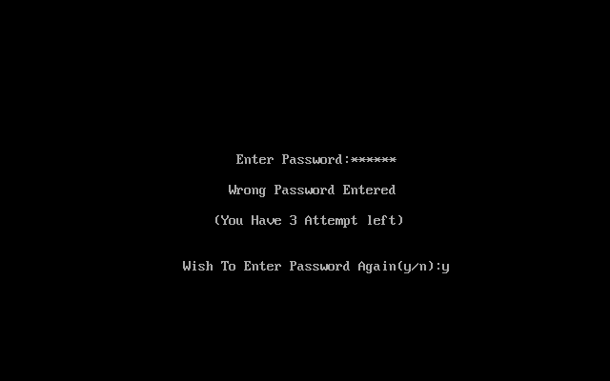

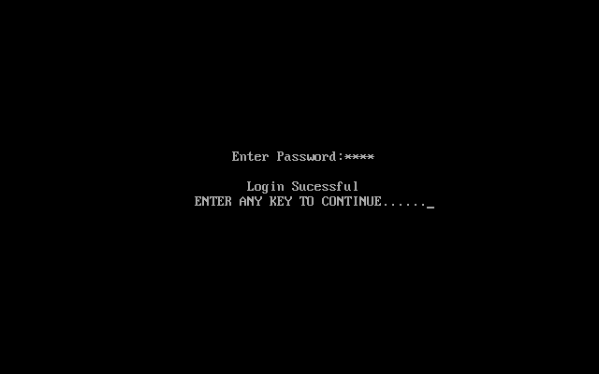

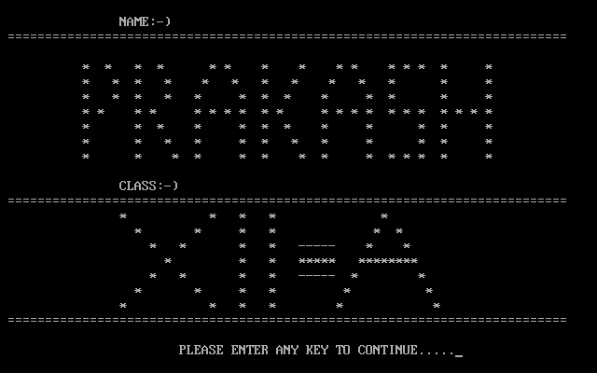

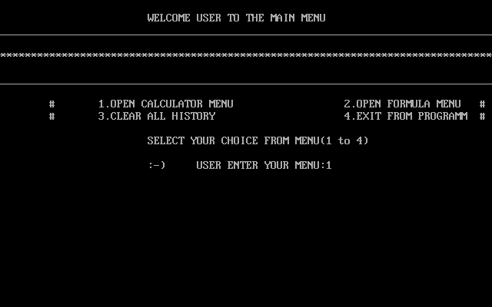

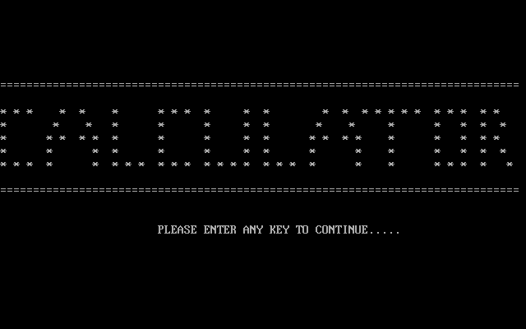

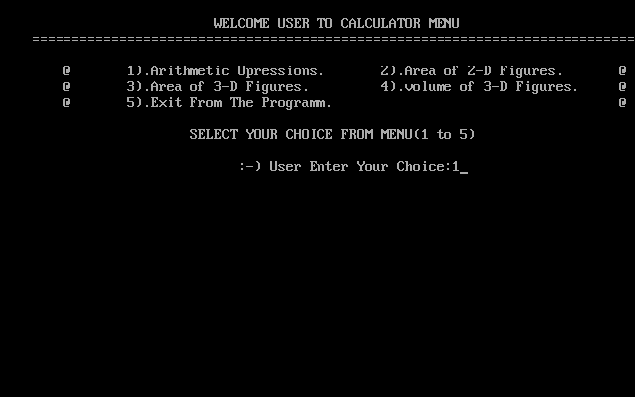

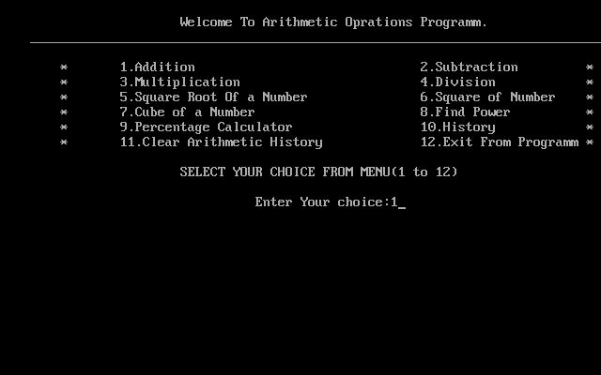

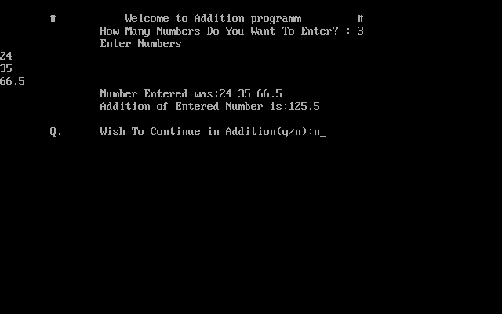

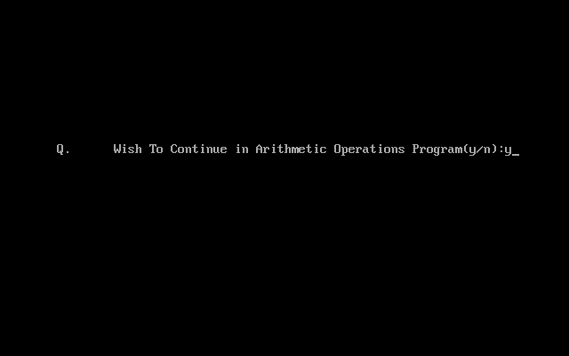

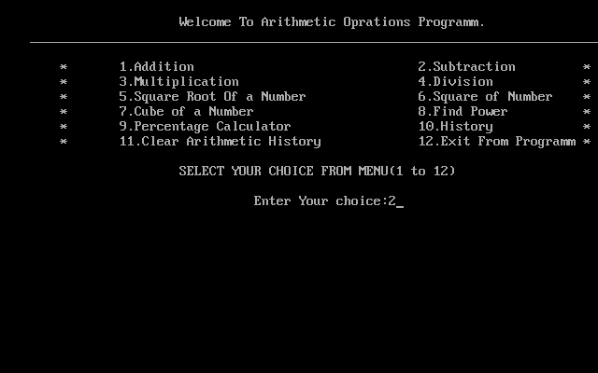

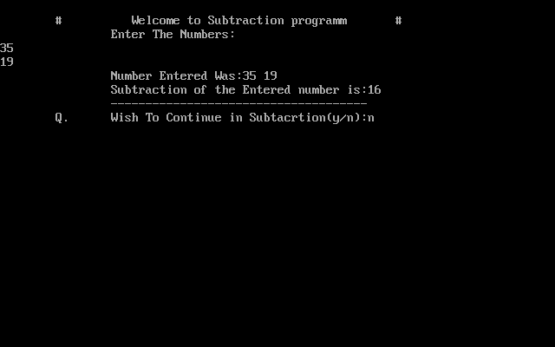

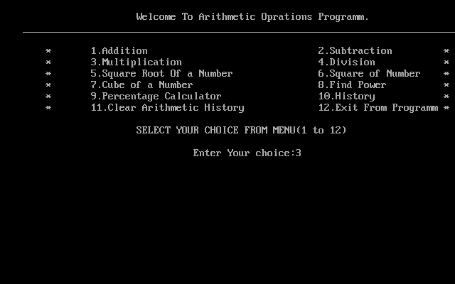

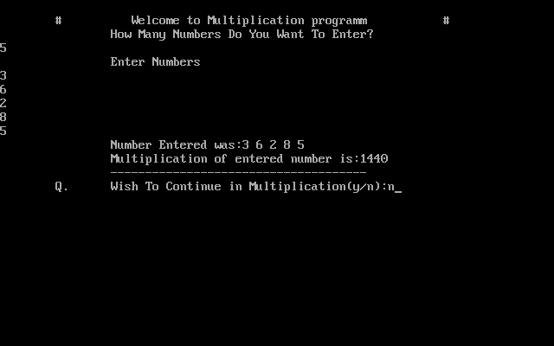

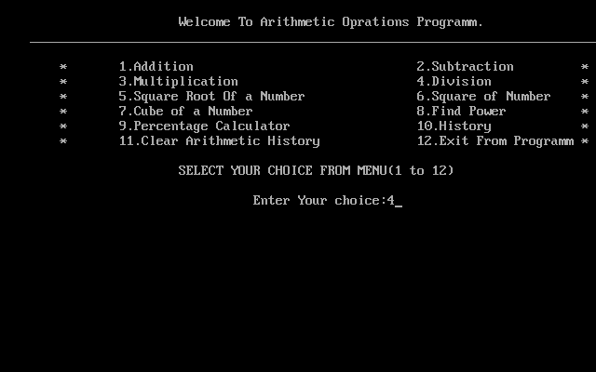

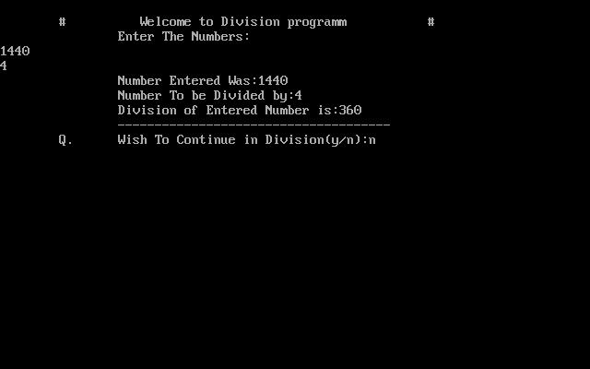

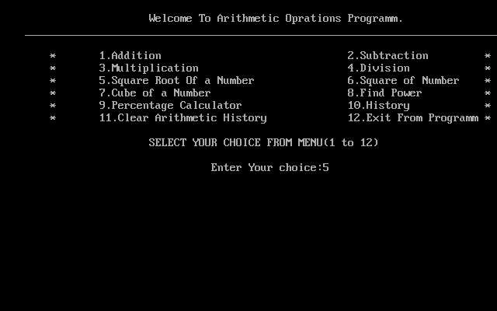

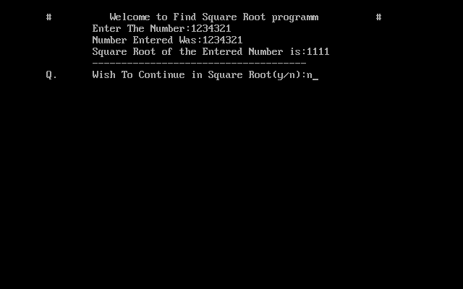

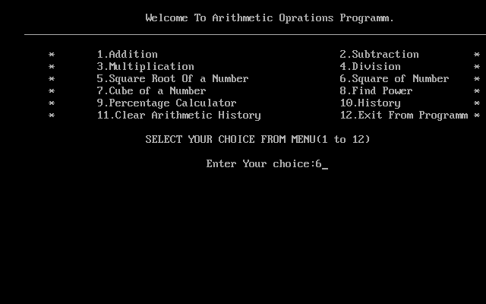

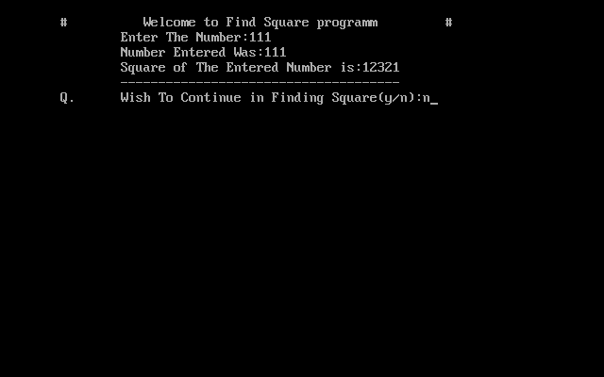

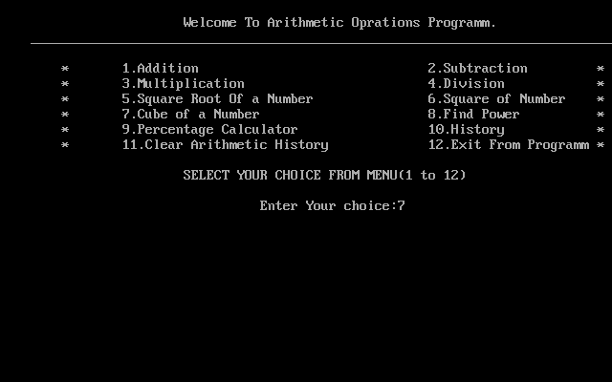

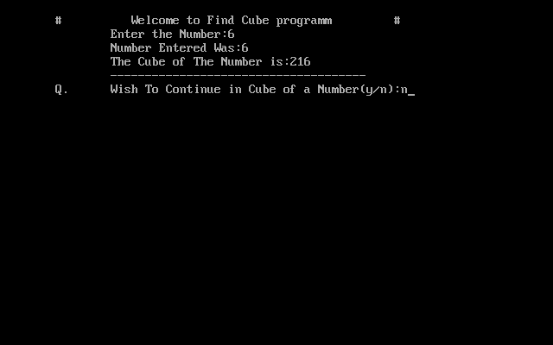

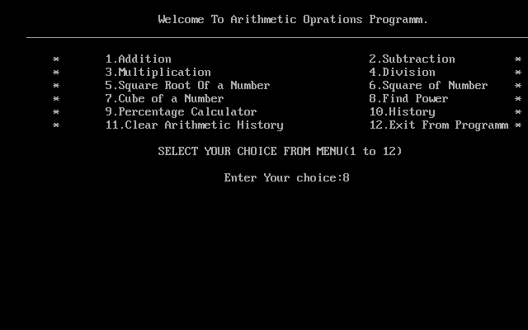

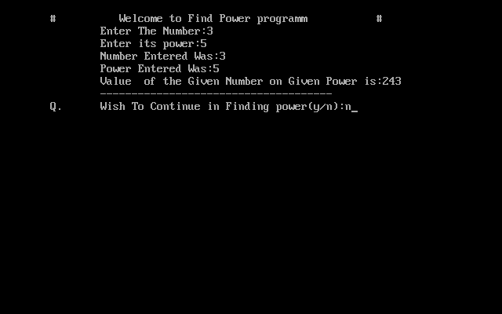

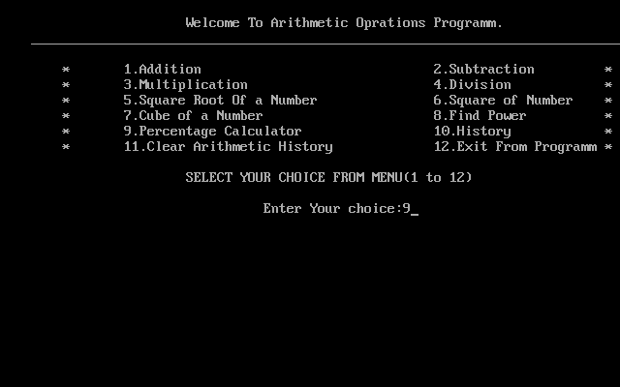

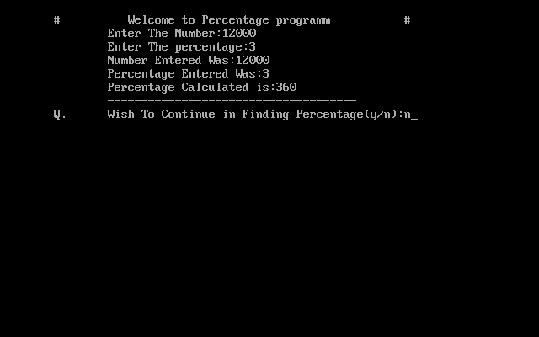

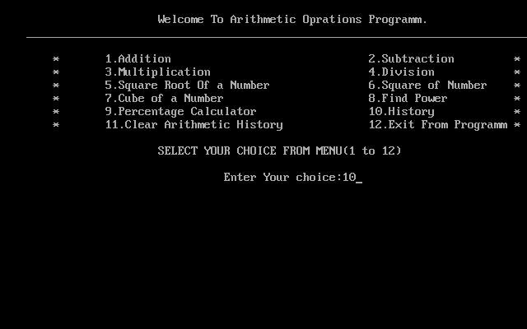

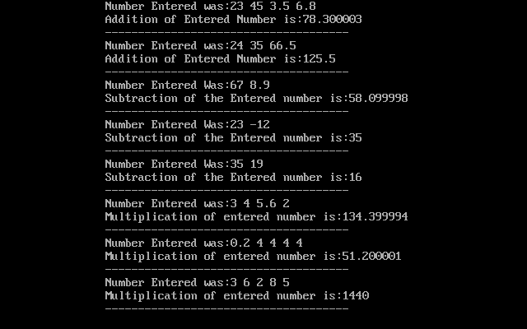

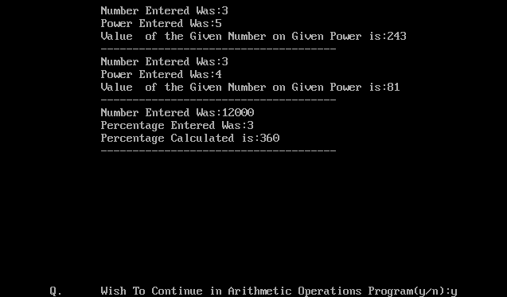

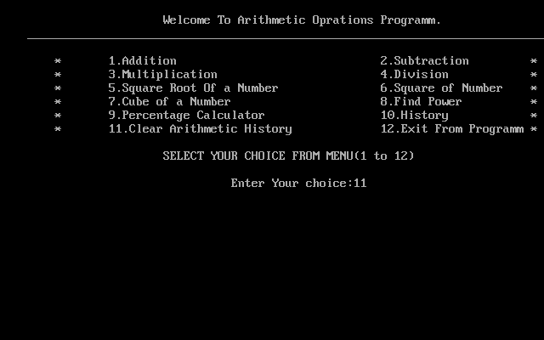

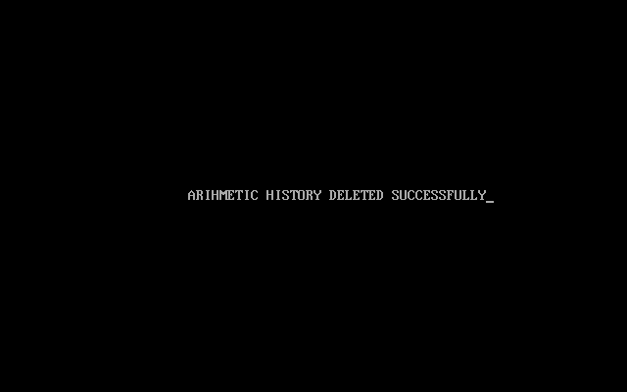

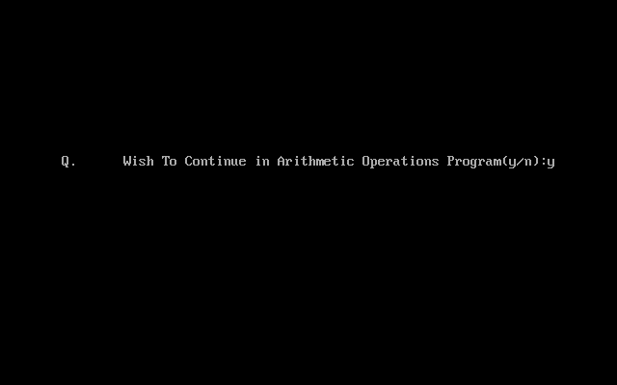

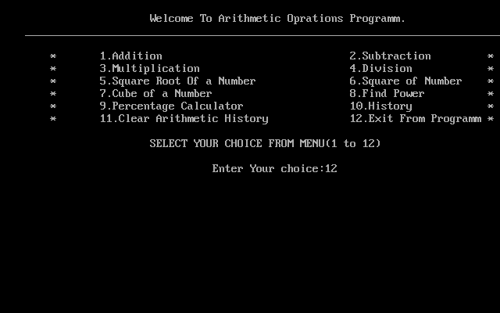

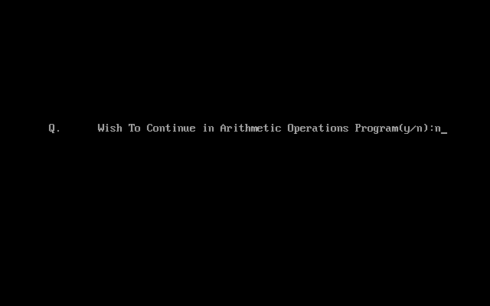

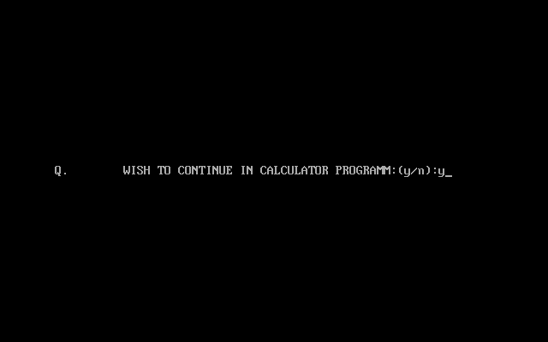

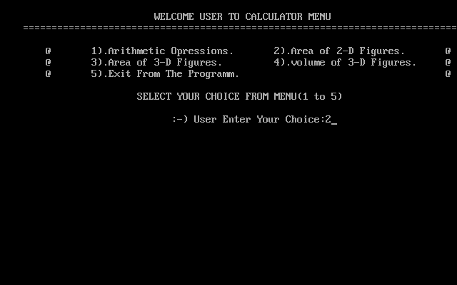

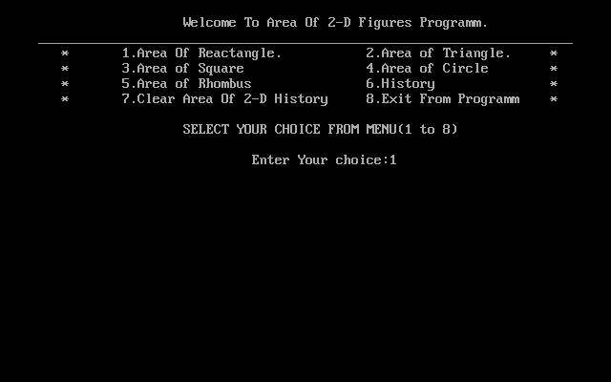

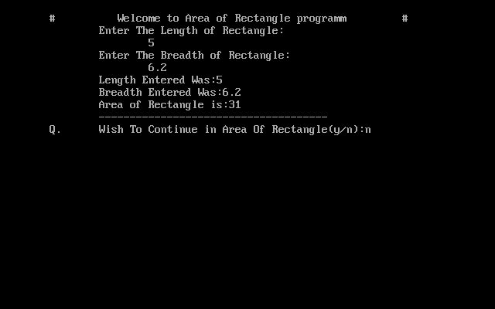

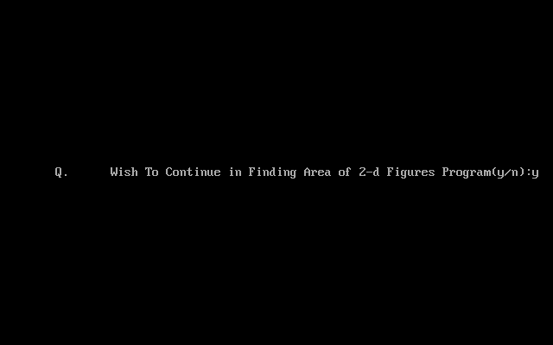

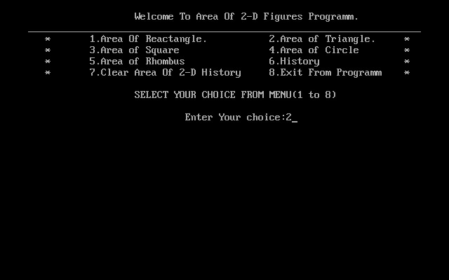

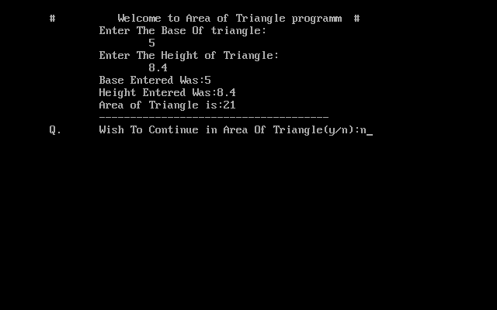

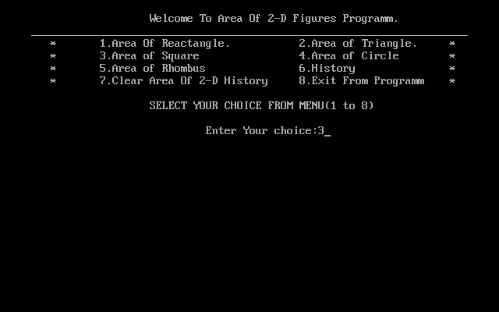

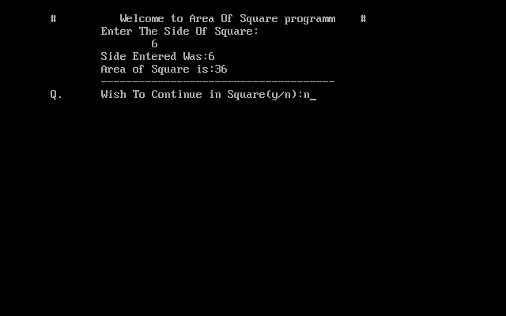

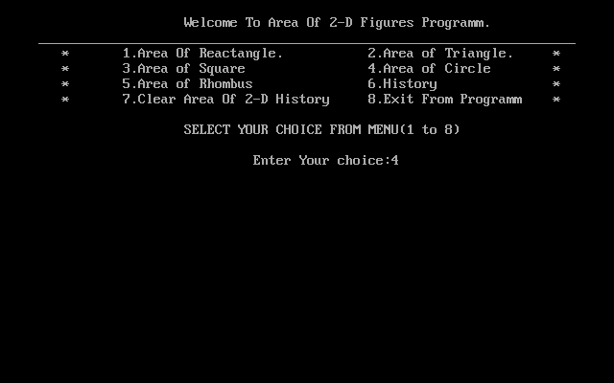

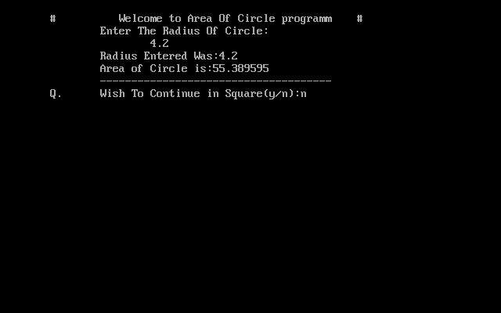

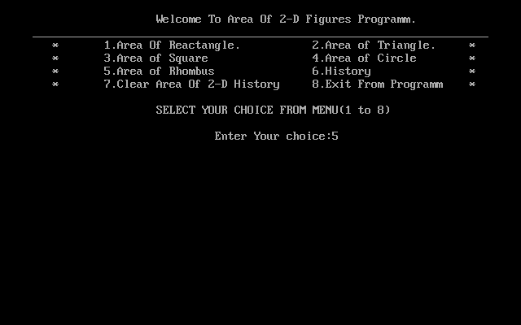

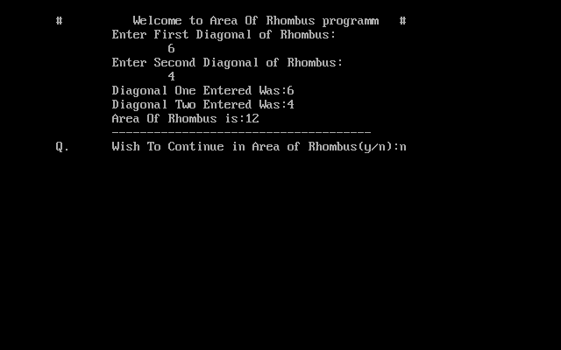

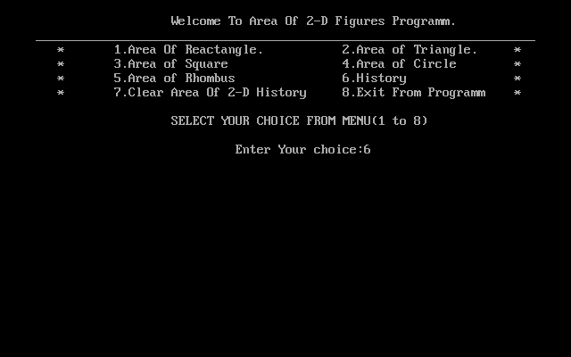

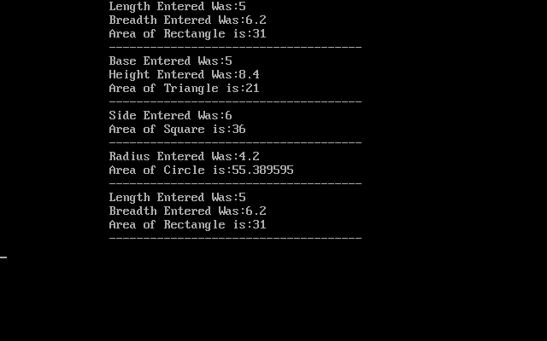

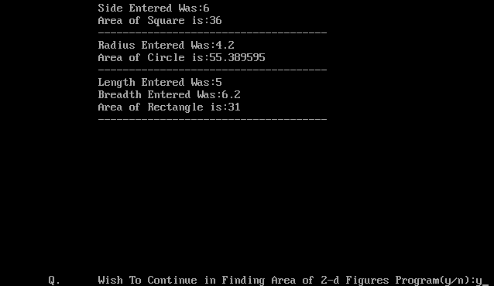

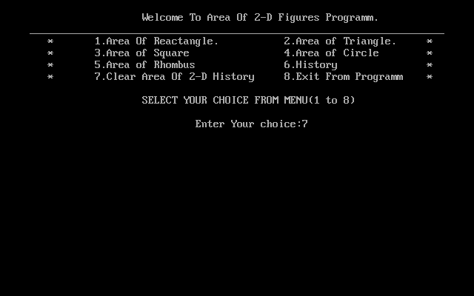

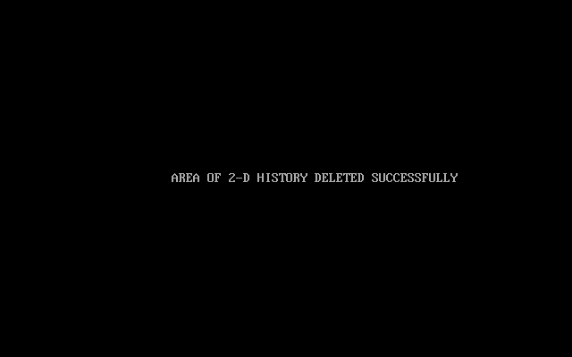



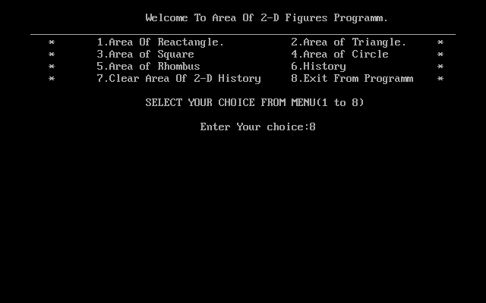

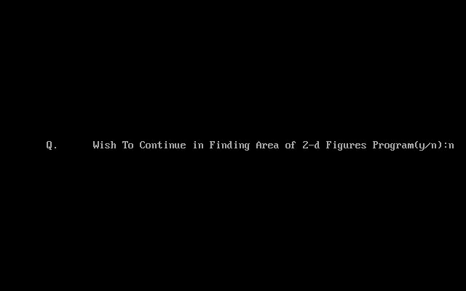



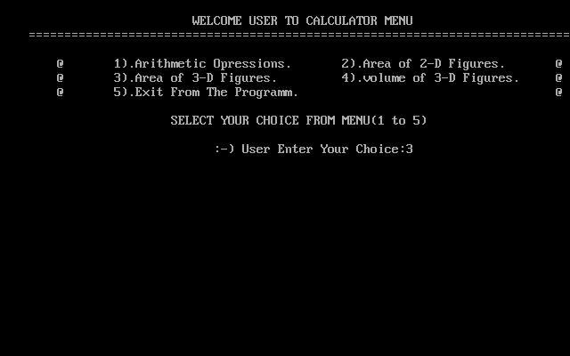

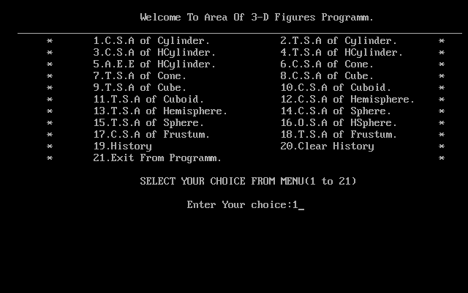

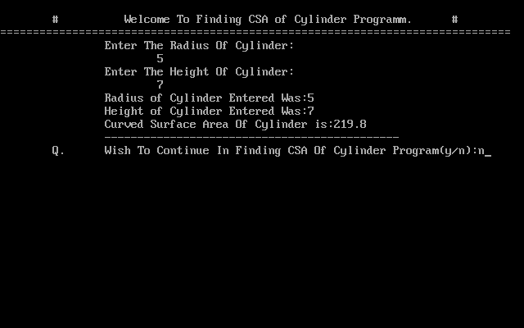

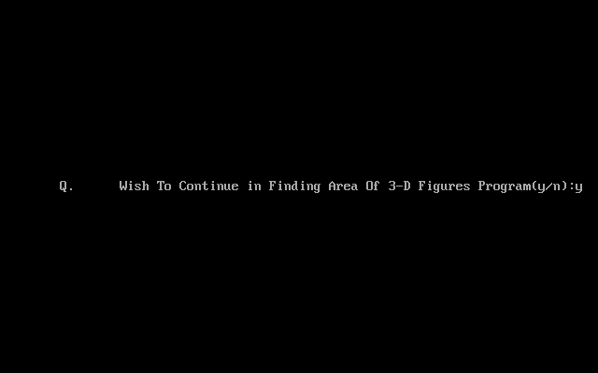

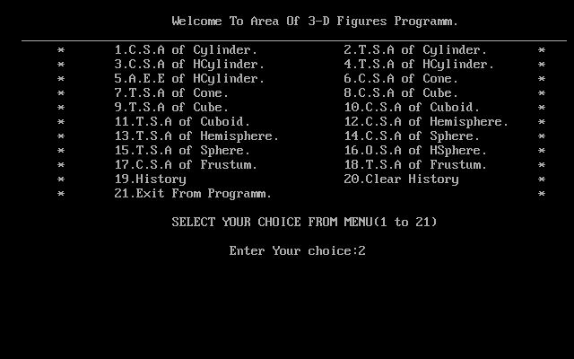

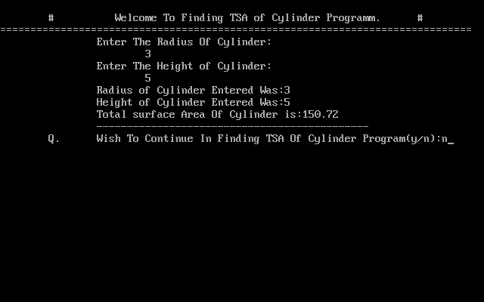

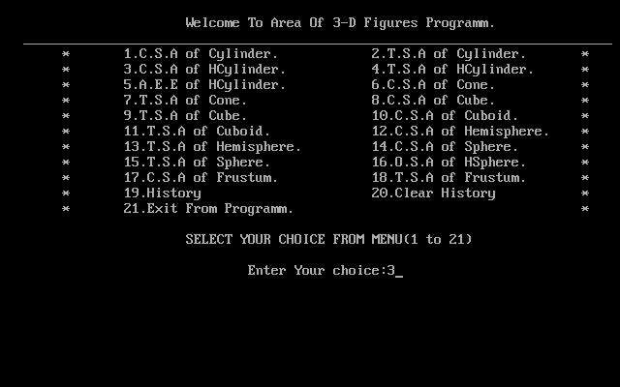

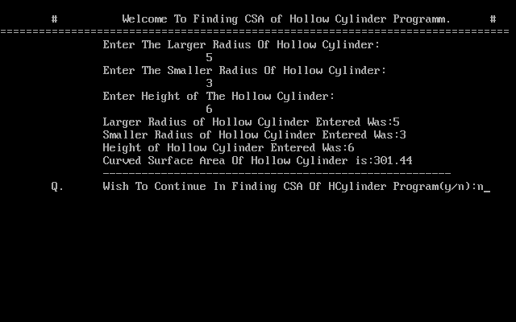

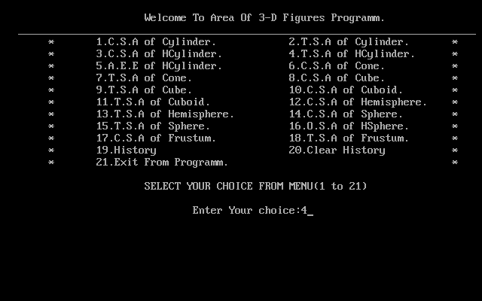

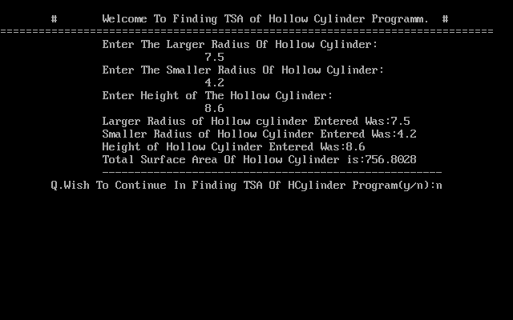

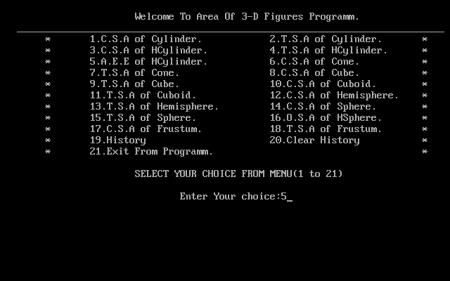

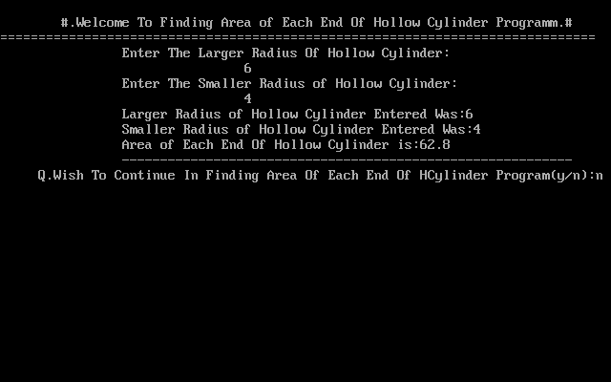

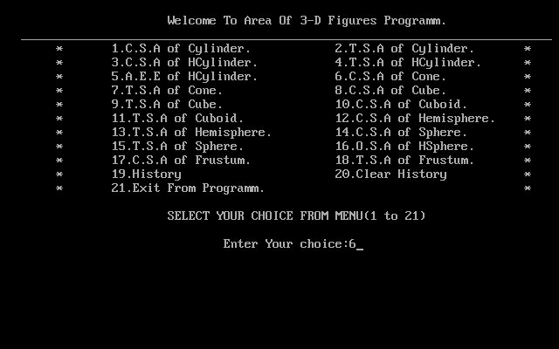

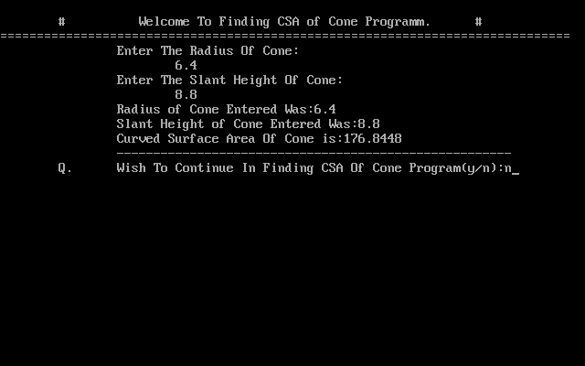

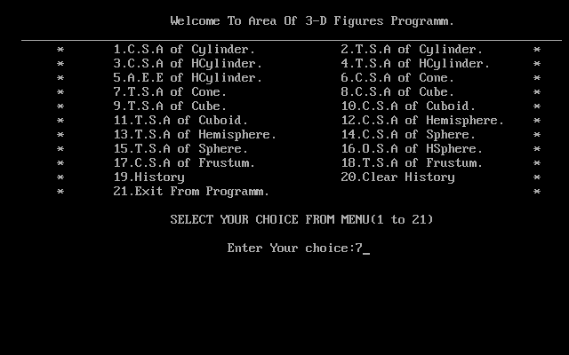

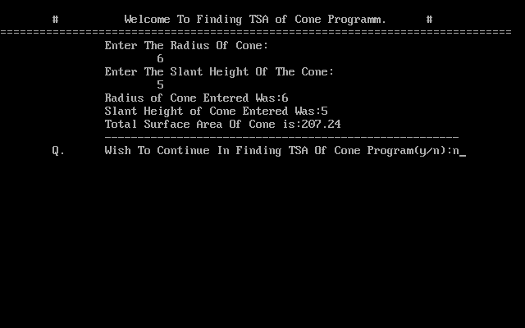

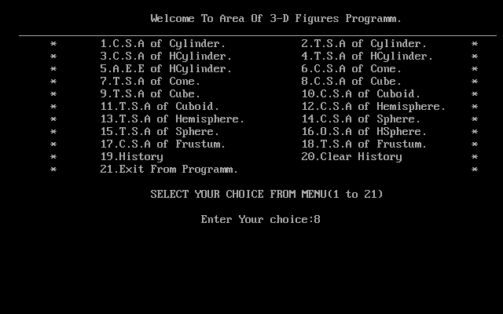

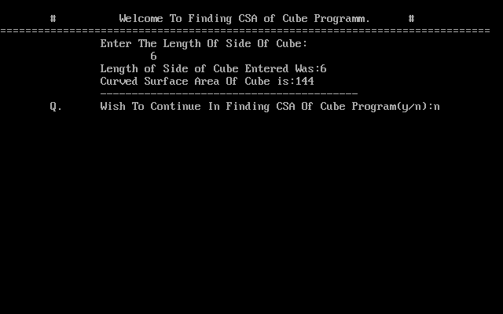

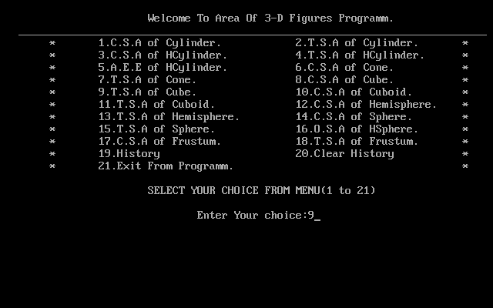

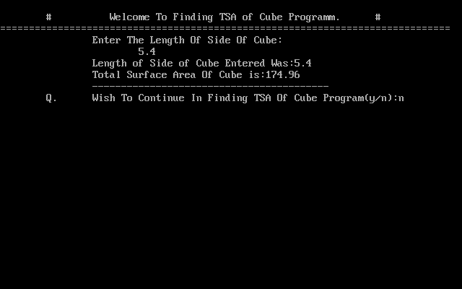

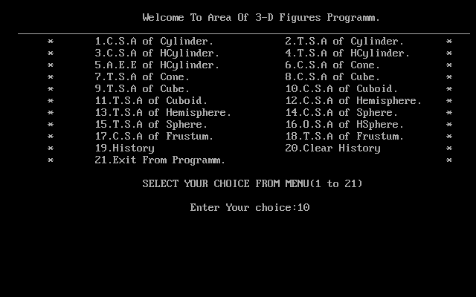

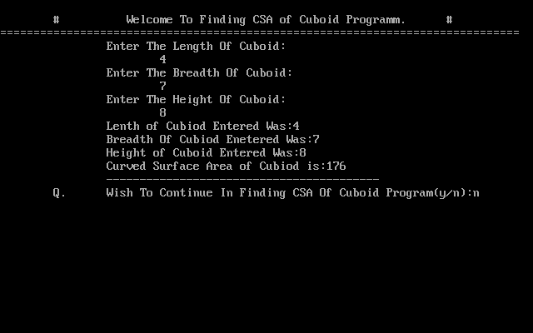

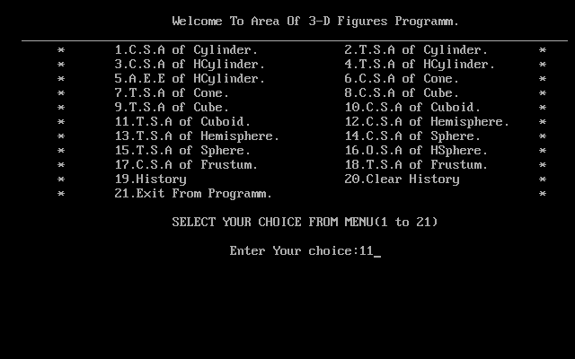

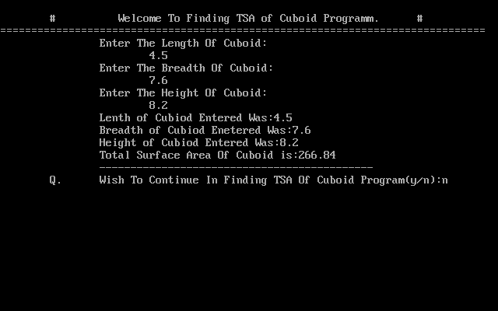

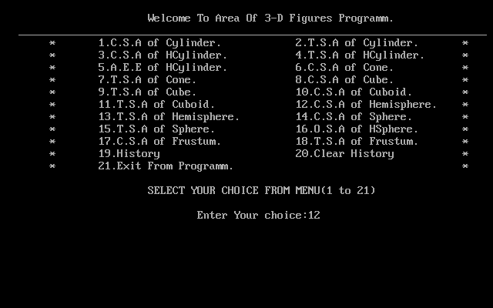

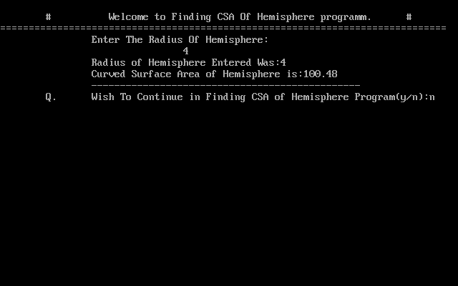

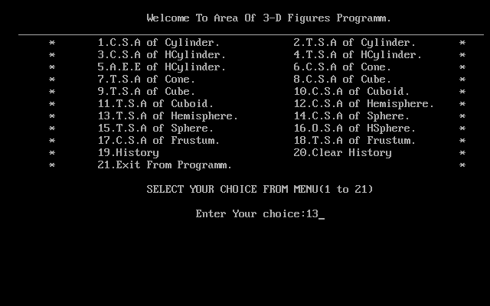

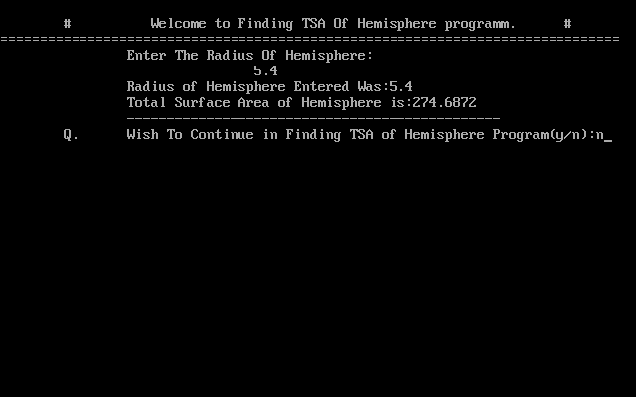

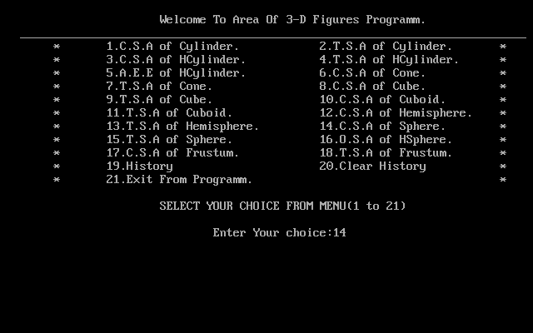

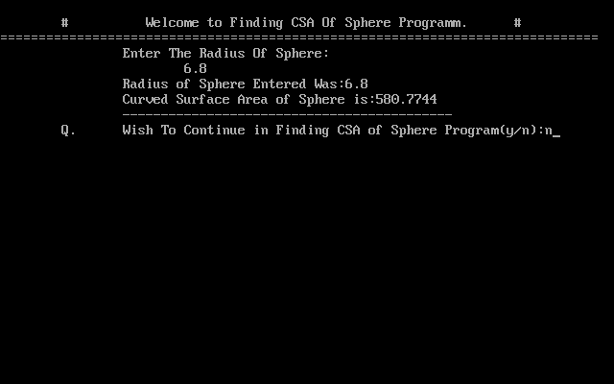

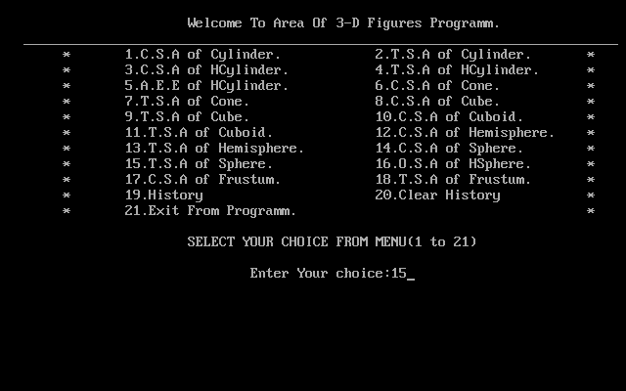

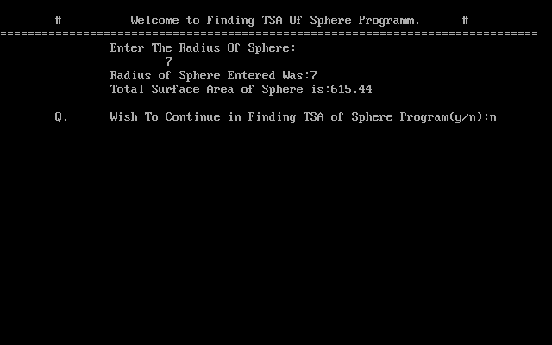

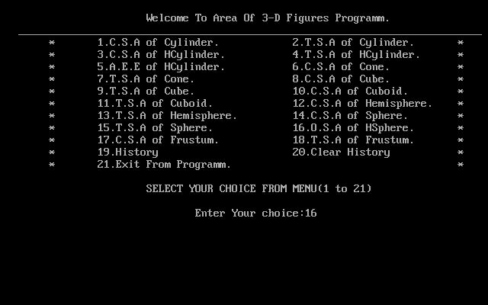

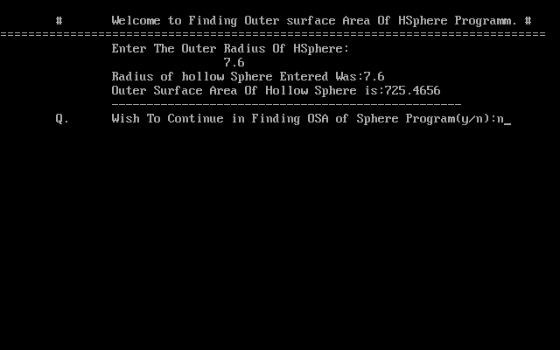

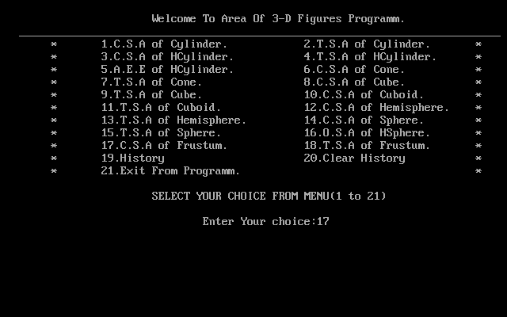

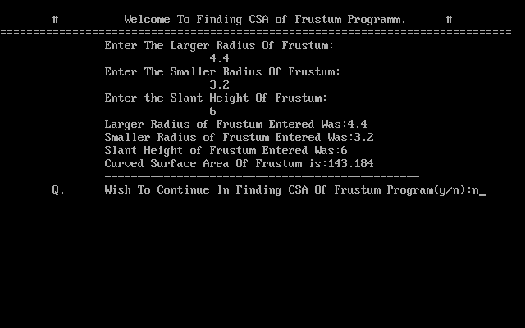

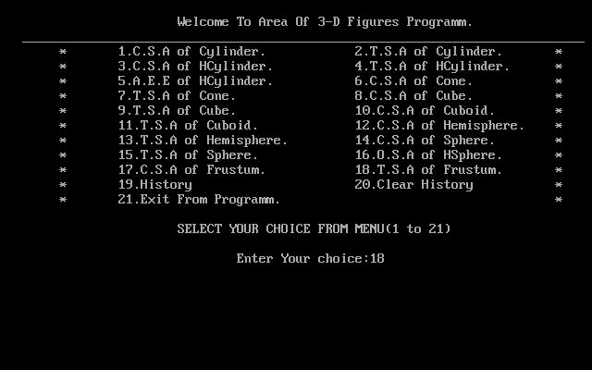

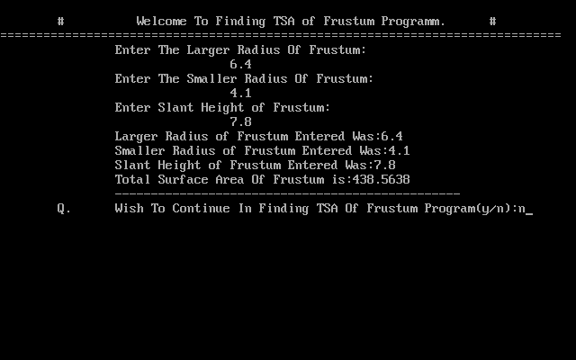

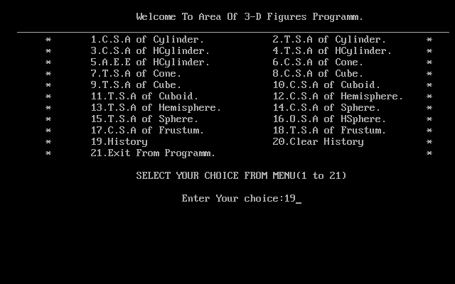

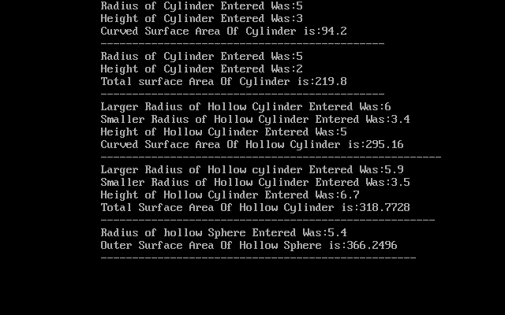

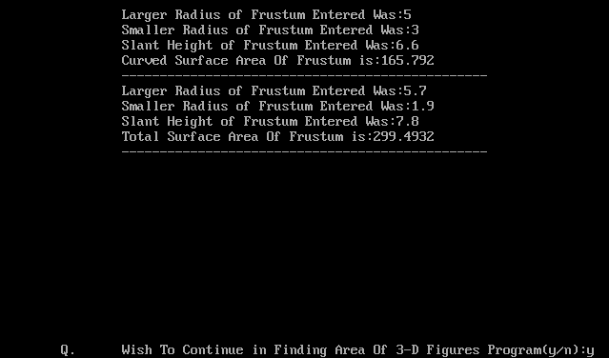

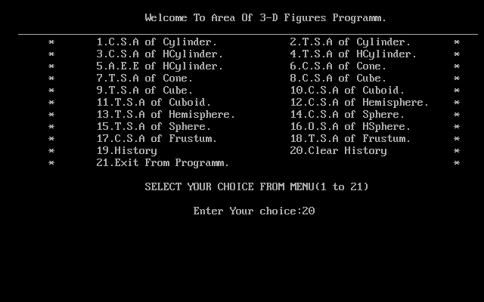

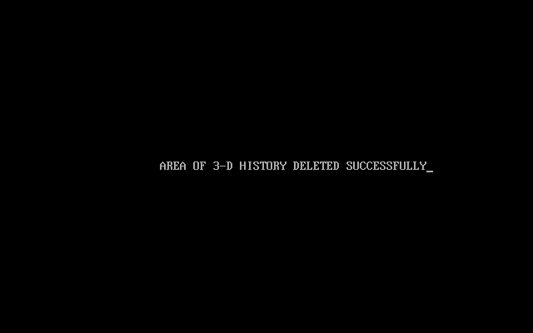



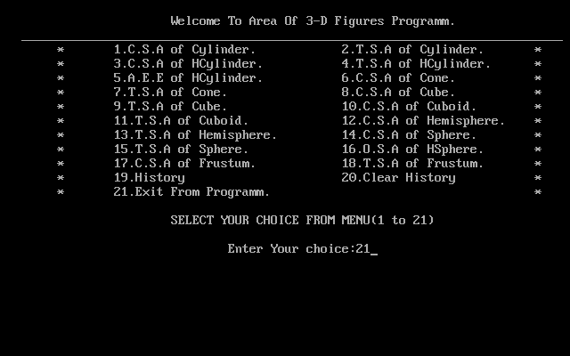

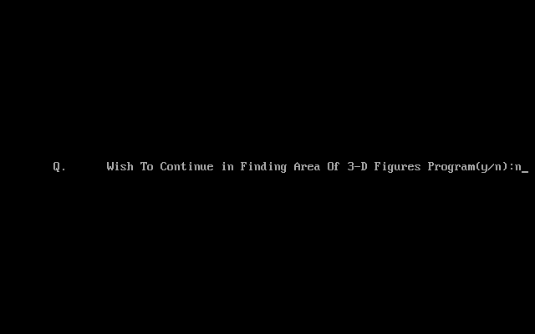



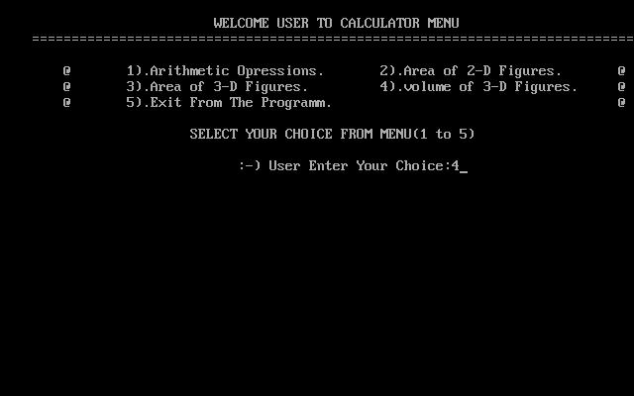

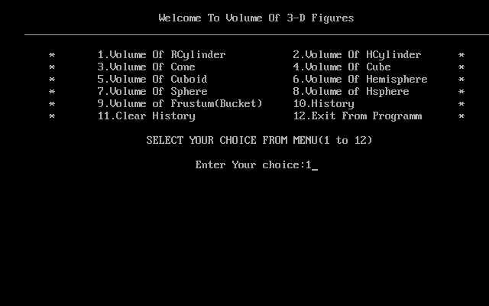

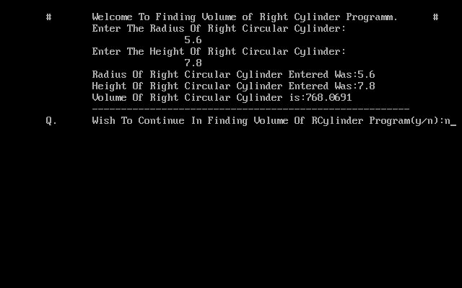

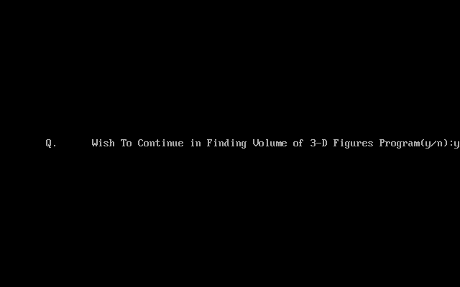

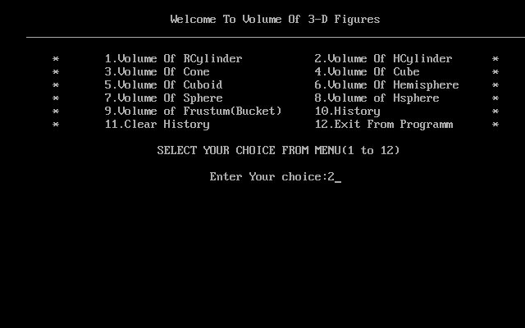

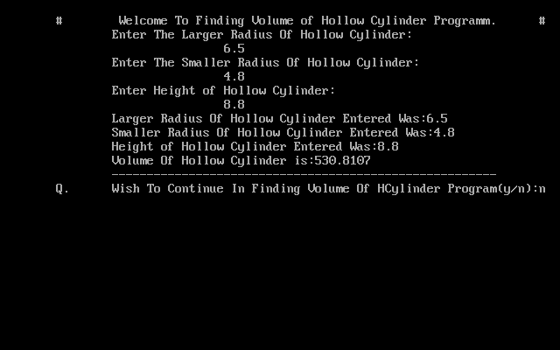

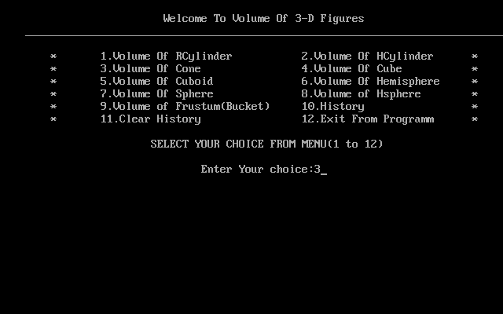

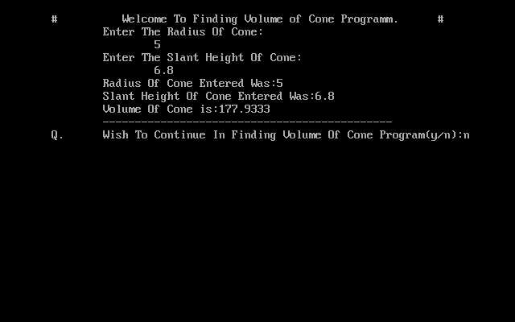

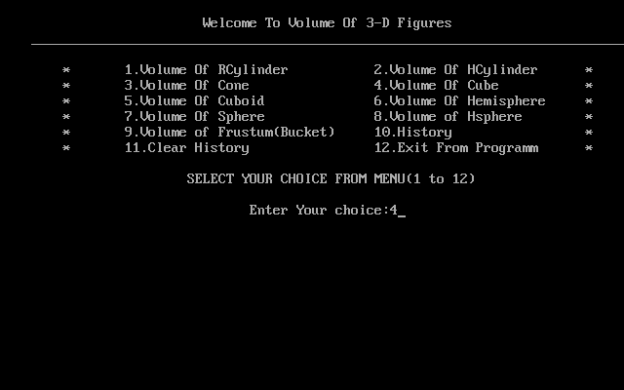

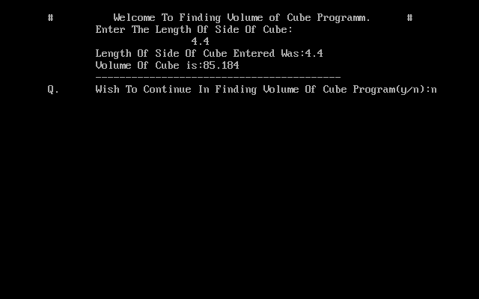

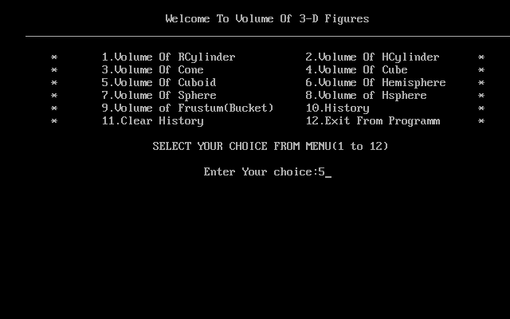

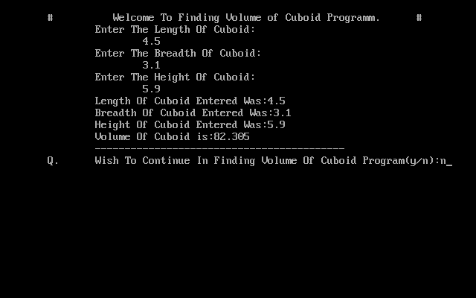

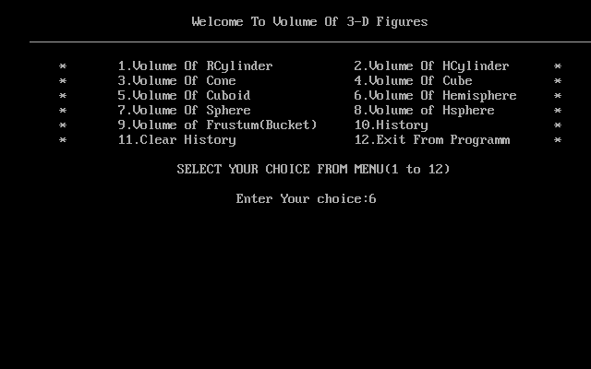

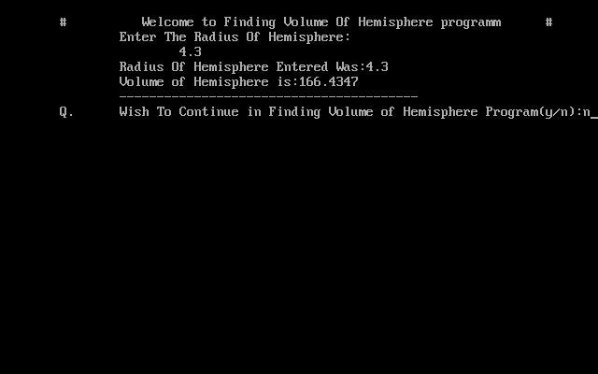

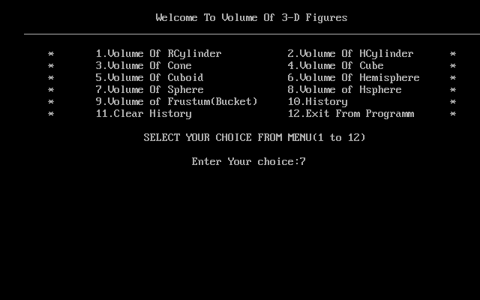

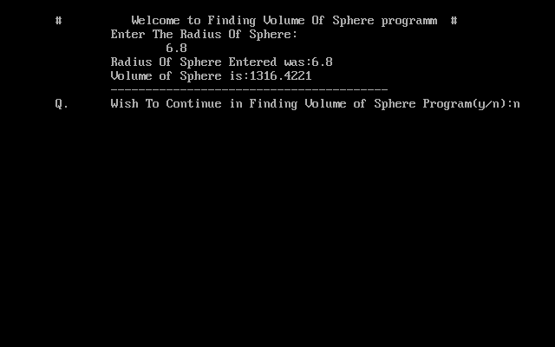

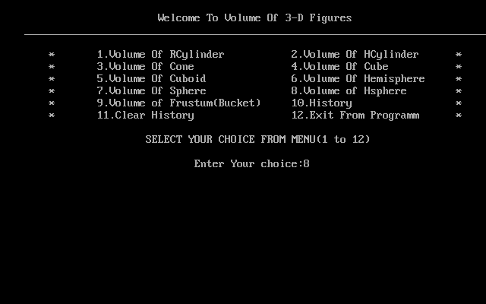

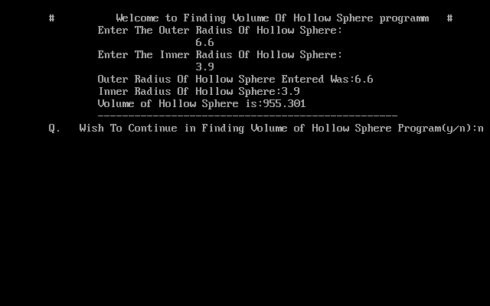

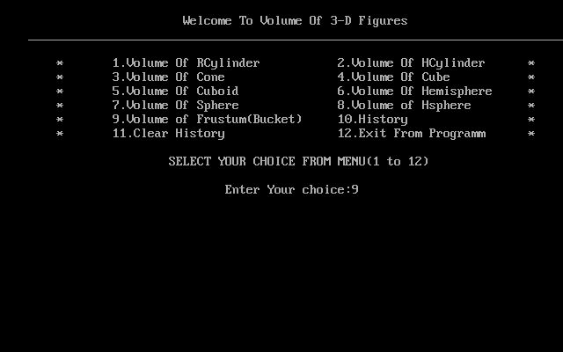

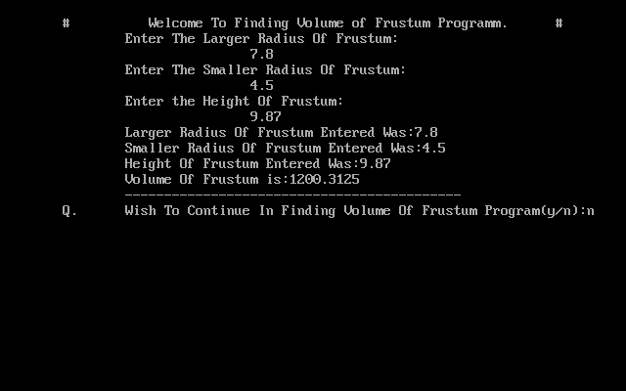

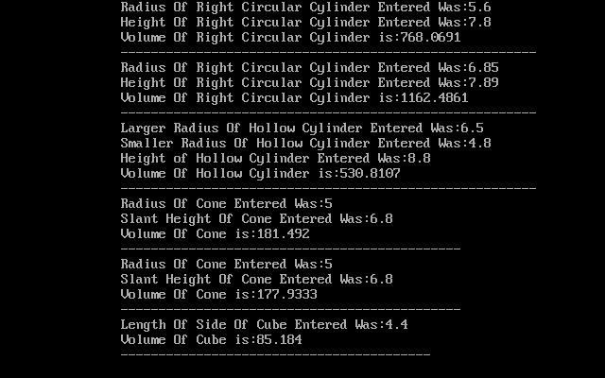

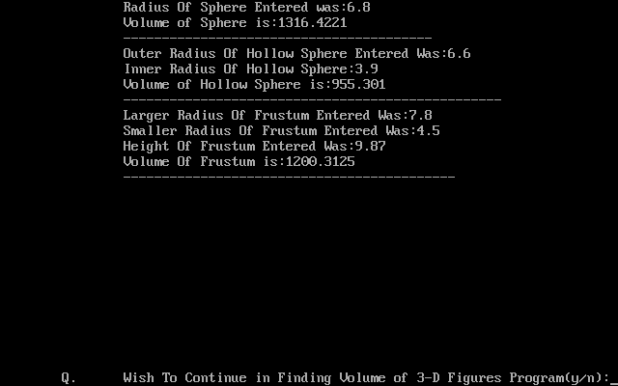

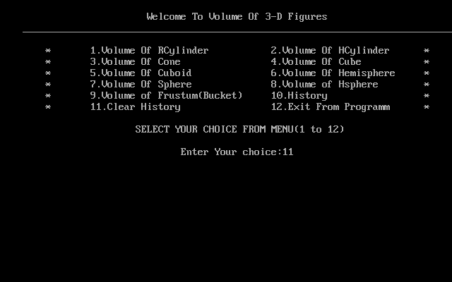



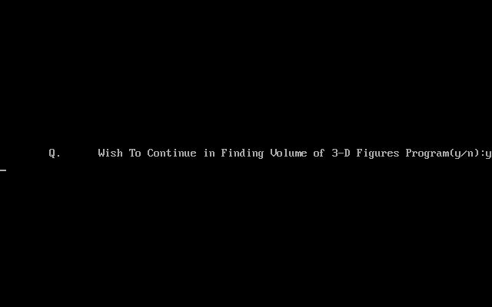

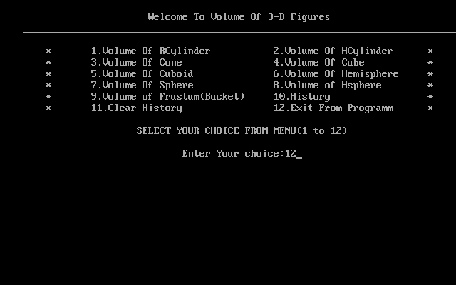

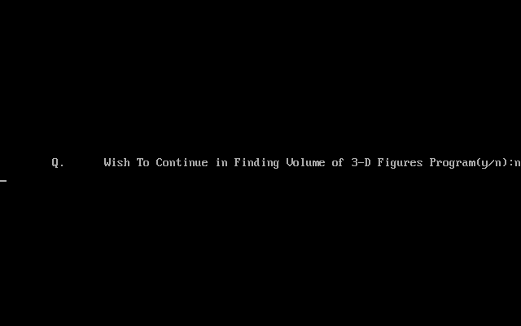

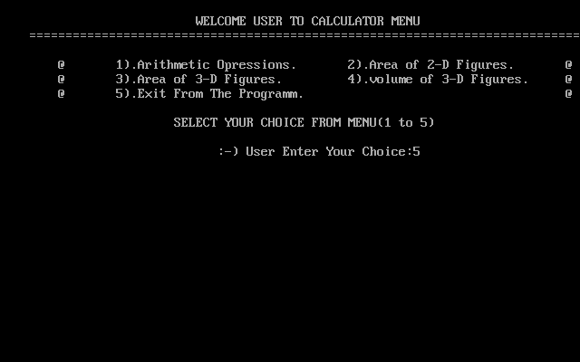

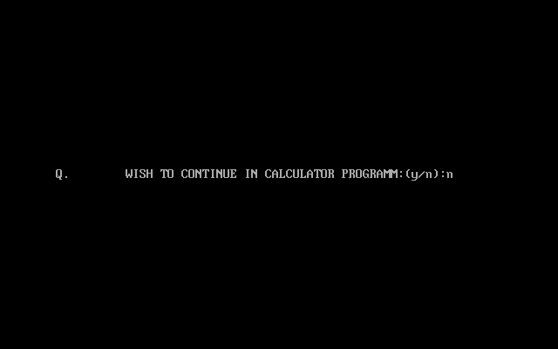

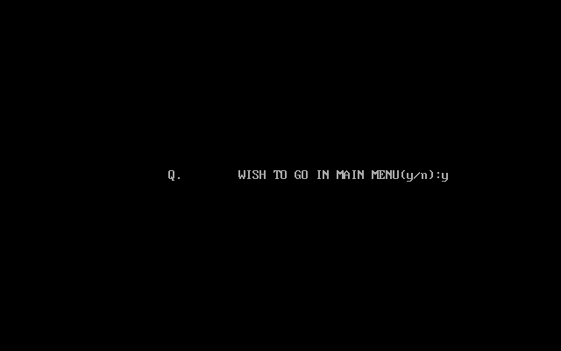

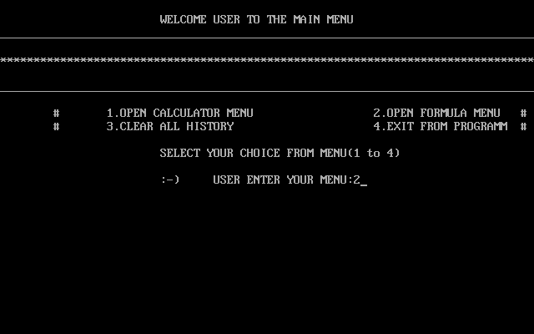

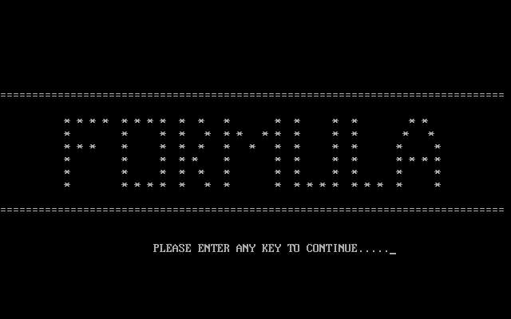

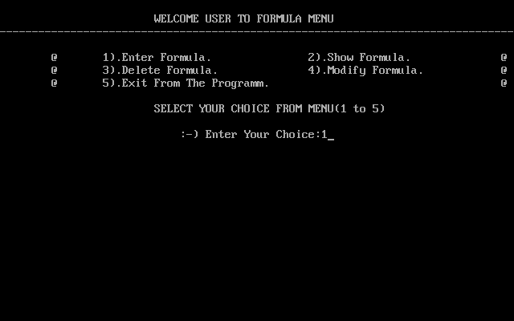

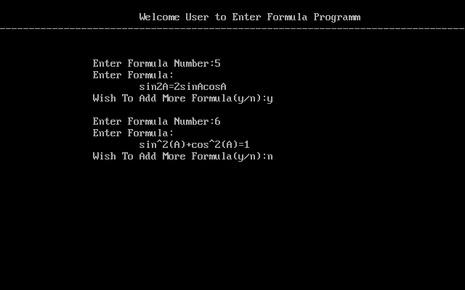

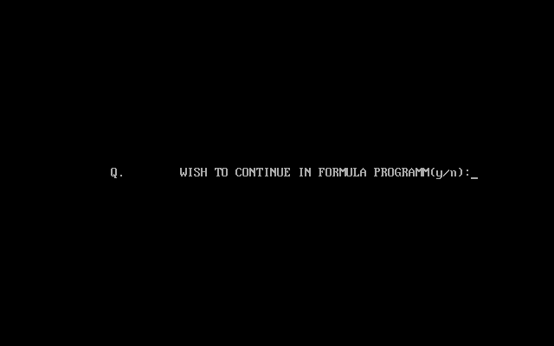

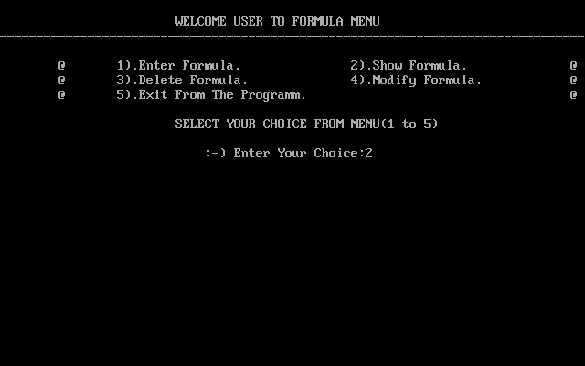

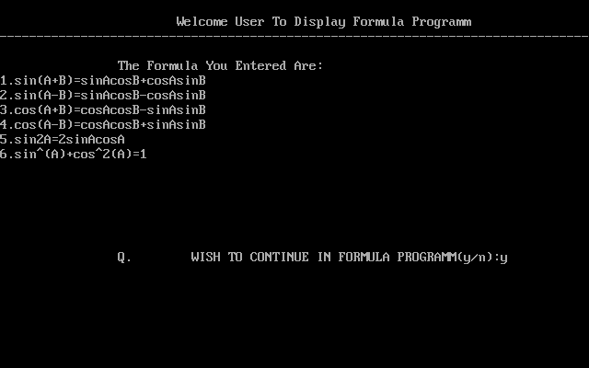

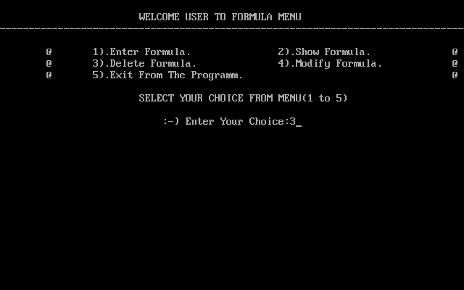

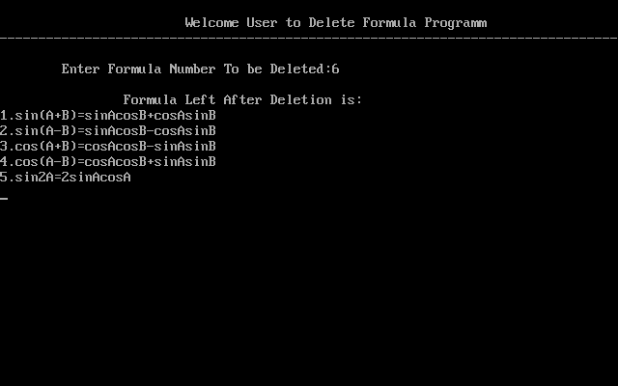

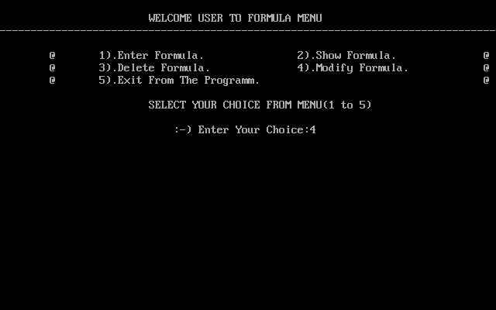

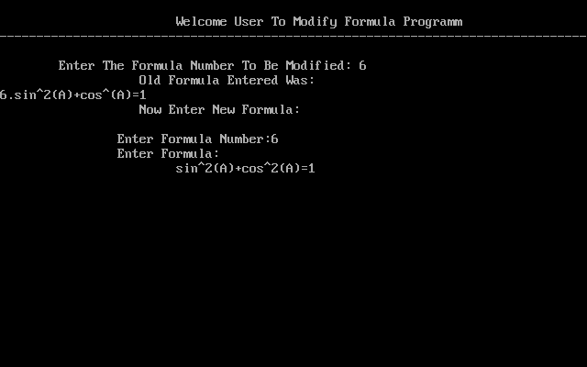

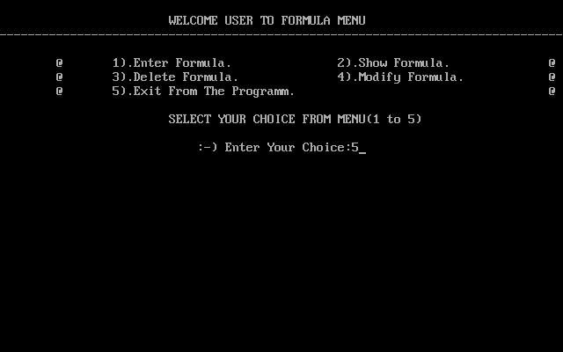

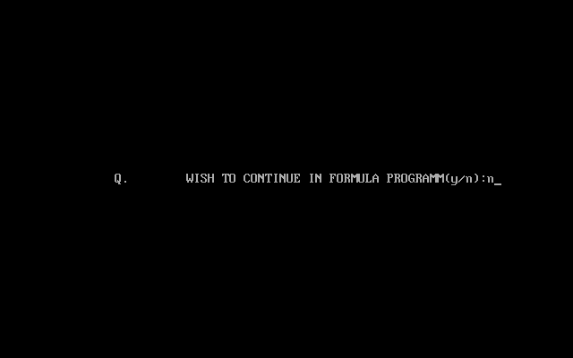



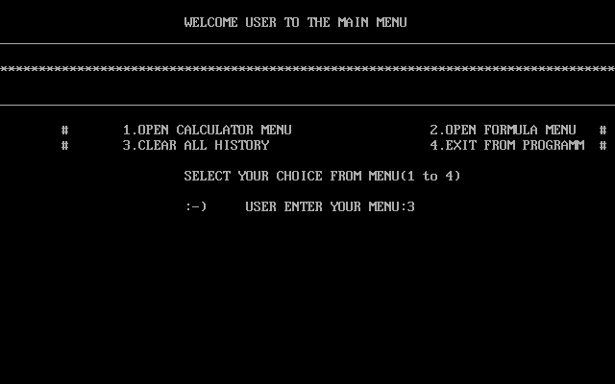

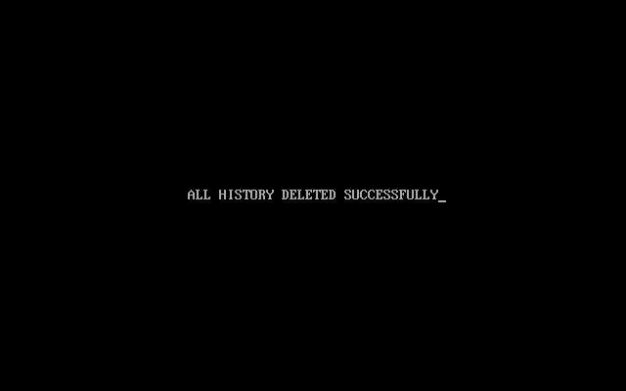



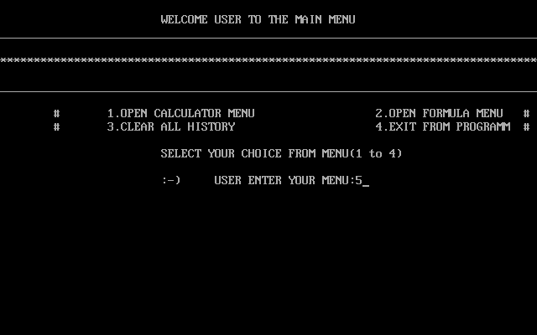

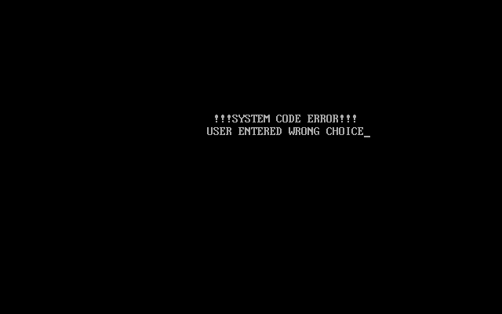



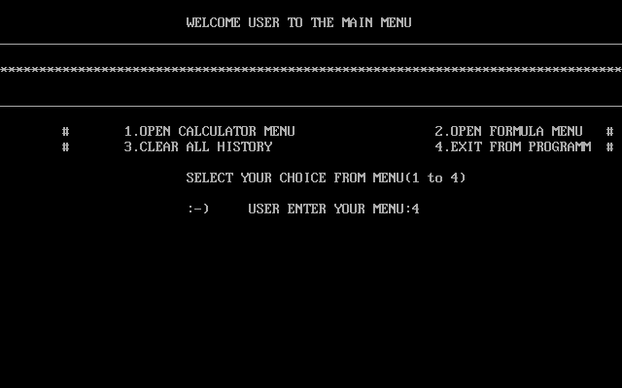

**GO BACK TO**

**CODING😊**

**BIBLIOGRAPHY**

* Computer Science Textbook class XI and XII by Sumita Arora.
* Computer Science Textbook class XII by Preeti Arora.